NOTICES

ST. STEPHEN’S CHAPEL The Family Flower for July is from the Dowse family in loving memory of husband and father, Peter.


KITCHEN APPEAL You will see posters and a flyer you have been given about our Kitchen Appeal. Anyone who has been in our kitchen can see how much it needs improvement. We want to future proof our new kitchen so it is ready for whatever St Andrew’s provides in the future from café style tea and coffee to full meals on a regular or occasional basis. We will replace the kitchen in August. Please give generously.

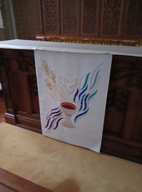
ALTAR FALL There is a new Altar Fall on the Altar in St Stephen's Chapel, which was designed and made by Julia Hemingray, who made our other new pieces. As before, if you would like to make a donation towards the cost in memory of a loved one or to celebrate a special anniversary or occasion, please speak to me or message on 07889 249500. Many thanks Wendy Godwin

BADMINTON We play badminton on Monday evenings from 8 till 10pm in the main hall. We'd love some new members so please give me a ring if you'd like to come along! Gill Moore

ST. ANDREW’S CHURCH Our prayers have been answered, we now have £500 to spend on gazebos/event shelters to protect us from sun and rain as we continue our outdoor activities. Susan McLeod
bank details for one-off payments and gifts -
PCC of St Andrew's Roxbourne Parish
Sort code: 40-11-58 Acc No: 20404810
Please note this is not the account for regular Stewardship Giving - please see Wendy Godwin or Peter Sage for those details (Tel: 07889 249500)

PRAYER FOR THE WEEK

Thank you for the extravagant seeds of your word. I pray today that you soften the soil of my heart. Clear away the hardened path of distraction, uproot the worries of this world, and break through the shallow, rocky places. Help me to be good soil, receiving your truth, letting its roots grow deep, and bearing fruit in your love.
S^{T} ANDREW'S CHURCH, ROXBOURNE
 | 89 Malvern Avenue Harrow HA2 9ER.  020 8422 3633 www.standrewsroxbourne.org.uk  Registered Charity No. 1131727 | 

Star Link

SUNDAY, 12th JULY TRINITY 6
Roxbournestandrews



8.00 am: Holy Communion
10.00 am: Parish Communion
and Children’s Church
Please come to the Hall after the Service for Coffee, Tea & Fellowship

This Week’s Services |  | Next Sunday 19th July
Monday – Friday 9am Morning Prayer  Wednesday 9.30 Communion |  | 8.00 am: Holy Communion  10.00 am: Parish Communion  Isaiah 44: 6-8; Romans 8: 12-25;  Matthew 13: 24-30 & 36-43
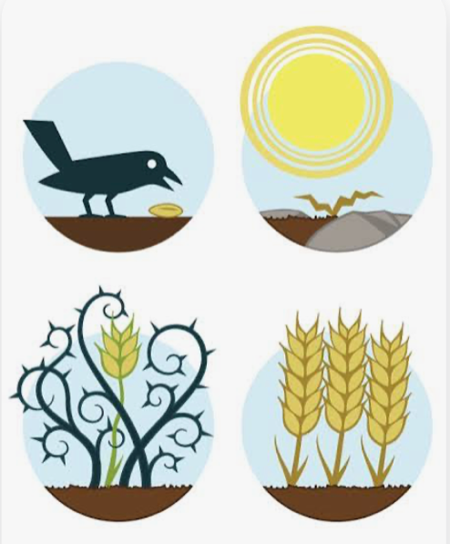

TODAY’S COLLECT

Creator God, you made us all in your image: may we discern you in all that we see, and serve you in all that we do; through Jesus Christ our Lord. Amen

TODAY’S READINGS
Isaiah 55: 10-13
As the rain and the snow come down from heaven, and do not return to it without watering the earth and making it bud and flourish, so that it yields seed for the sower and bread for the eater, so is my word that goes out from my mouth: It will not return to me empty, but will accomplish what I desire and achieve the purpose for which I sent it. You will go out in joy and be led forth in peace; the mountains and hills will burst into song before you, and all the trees of the field will clap their hands. Instead of the thorn bush will grow the juniper, and instead of briers the myrtle will grow. This will be for the Lord’s renown, for an everlasting sign, that will endure forever.”

Romans 8: 1-11
Therefore, there is now no condemnation for those who are in Christ Jesus, because through Christ Jesus the law of the Spirit who gives life has set you free from the law of sin and death. For what the law was powerless to do because it was weakened by the flesh, God did by sending his own Son in the likeness of sinful flesh to be a sin offering. And so he condemned sin in the flesh, in order that the righteous requirement of the law might be fully met in us, who do not live according to the flesh but according to the Spirit. Those who live according to the flesh have their minds set on what the flesh desires; but those who live in accordance with the Spirit have their minds set on what the Spirit desires. The mind governed by the flesh is death, but the mind governed by the Spirit is life and peace. The mind governed by the flesh is hostile to God; it does not submit to God’s law, nor can it do so. Those who are in the realm of the flesh cannot please God. You, however, are not in the realm of the flesh but are in the realm of the Spirit, if indeed the Spirit of God lives in you. And if anyone does not have the Spirit of Christ, they do not belong to Christ. But if Christ is in you, then even though your body is subject to death because of sin, the Spirit gives life[ because of righteousness. And if the Spirit of him who raised Jesus from the dead is living in you, he who raised Christ from the dead will also give life to your mortal bodies because of his Spirit who lives in you.

Matthew 13: 1-9 & 18-23
That same day Jesus went out of the house and sat beside the lake. Such great crowds gathered around him that he got into a boat and sat there, while the whole crowd stood on the beach. And he told them many things in parables, saying: ‘Listen! A sower went out to sow. And as he sowed, some seeds fell on the path, and the birds came and ate them up. Other seeds fell on rocky ground, where they did not have much soil, and they sprang up quickly, since they had no depth of soil. But when the sun rose, they were scorched; and since they had no root, they withered away. Other seeds fell among thorns, and the thorns grew up and choked them. Other seeds fell on good soil and brought forth grain, some a hundredfold, some sixty, some thirty. Let anyone with ears listen!’
‘Hear then the parable of the sower. When anyone hears the word of the kingdom and does not understand it, the evil one comes and snatches away what is sown in the heart; this is what was sown on the path. As for what was sown on rocky ground, this is the one who hears the word and immediately receives it with joy; yet such a person has no root, but endures only for a while, and when trouble or persecution arises on account of the word, that person immediately falls away. As for what was sown among thorns, this is the one who hears the word, but the cares of the world and the lure of wealth choke the word, and it yields nothing. But as for what was sown on good soil, this is the one who hears the word and understands it, who indeed bears fruit and yields, in one case a hundredfold, in another sixty, and in another thirty.’
POST COMMUNION PRAYER

God of our pilgrimage, you have led us to the living water: refresh and sustain us as we go forward on our journey, in the name of Jesus Christ our Lord.
Amen
PRAYER DIARY

RIP: Chaymae Mrabet, Ann Widdecombe.

This week we remember with thanksgiving the anniversaries of Florence Leighton; Deborah Currens (14th); Ann George (17th); William Judge (18th),
Mary Cook.

Prayer request for healing and other needs: Sue Broatch; Elizabeth Bello; Malcolm George; Joyce Nickolay; Pam Storey; Easterine Suresh; Belinda Szamanski, Martin Voles; Gary Williams; Angela Zadurian.

Happy Birthday to Shirley Bullion (14th); Julie Harris (15th); Sue Broatch (16th); Bethany Collins (18th).
Church families: Russell, Lara, Hezekiah and Jesse Simonot; Alestir, Naomi and Sandra Smith-Alleyne; Pam Storey; Anushka Swan; Belinda Szymanski; Emma, Freya and Leone Thakrar; Alan, Elizabeth, Marina, and Edward Tinsey; Chris and Marian Twentyman.
The Parish: Lynwood Close; Malvern Avenue; Meadfield; Merlins Avenue; Minehead Court; Minehead Road; Mirren Close; Newlyn Gardens; Newquay Crescent.
