NOTICES

QUIZ We had a very good quiz night with 42 people and 1 dog attending! Rebecca Pennells made an excellent quiz master. We raised £707.50 from the ticket sales and the raffle. So thank you to everyone who supported this event. Social Committee

NEW: DEEPER IN FAITH WOMEN’S GROUP A space to slow down, reflect, and grow deeper in faith together through Bible study and friendship on Thursday evening 7.30-9.30pm monthly starting 7th May in the Vicarage. Please speak to Irene Teo or Barbara North.

MESSY CHURCH The next Messy Church will be on Saturday, 9th May and the theme will be 'Jonah'. Any offers of help will be gratefully received. Thanks.
Gill Moore


CHRISTIAN AID BIG BREKKIE
Join us on Sunday 10th May from 8.45 – 9.45.
Hot and cold items available, all your favourites!
All donations to Christian Aid.

HARROW FOOD BANK There is a box at the back of the church for donations. It is taken every month to Harrow Food Bank; let’s see if we can beat last month’s total.

bank details for one-off payments and gifts -
PCC of St Andrew's Roxbourne Parish
Sort code: 40-11-58 Acc No: 20404810
Please note this is not the account for regular Stewardship Giving - please see Wendy Godwin or Peter Sage for those details (Tel: 07889 249500)
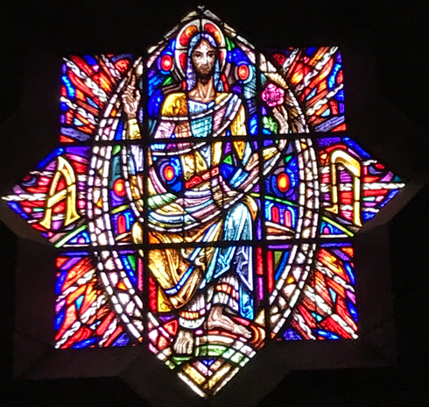

PRAYER FOR TODAY
Make me a tree, Lord,
Sturdy, Deep rooted, Useful,
Support to those in need,
Shelter to those who are weary,
Fruit for those who hunger.
Make me a tree, Lord,
Sturdy, Deep rooted, Useful.

S^{T} ANDREW'S CHURCH, ROXBOURNE
 | 89 Malvern Avenue Harrow HA2 9ER.  020 8422 3633 www.standrewsroxbourne.org.uk  Registered Charity No. 1131727 | 

Star Link

SUNDAY, 3rd MAY EASTER 5

We welcome Heathlands School Gospel Choir today.
Roxbournestandrews



8.00 am: Holy Communion
10.00 am: Parish Communion
and Children’s Church
Please come to the Hall after the Service for Coffee, Tea & Fellowship

This Week’s Services |  | Next Sunday 10th May
Monday – Friday 9am Morning Prayer  Wednesday 9.30 Communion |  | 8.00 am: Holy Communion  10.00 am: Parish Communion  Genesis 8: 1-19; Acts 7: 55-60; John 14: 1-14
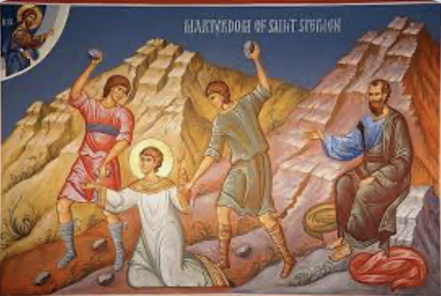
TODAY’S COLLECT

Risen Christ, your wounds declare your love for the world and the wonder of your risen life: give us compassion and courage to risk ourselves for those we serve, to the glory of God the Father. Amen
TODAY’S READINGS

1 Peter 2.2-10
Like newborn babies, crave pure spiritual milk, so that by it you may grow up in your salvation, now that you have tasted that the Lord is good. As you come to him, the living Stone—rejected by humans but chosen by God and precious to him— you also, like living stones, are being built into a spiritual house to be a holy priesthood, offering spiritual sacrifices acceptable to God through Jesus Christ. For in Scripture it says: “See, I lay a stone in Zion, a chosen and precious cornerstone, and the one who trusts in him will never be put to shame.” Now to you who believe, this stone is precious. But to those who do not believe, “The stone the builders rejected has become the cornerstone,” and, “A stone that causes people to stumble and a rock that makes them fall.” They stumble because they disobey the message—which is also what they were destined for. But you are a chosen people, a royal priesthood, a holy nation, God’s special possession, that you may declare the praises of him who called you out of darkness into his wonderful light. Once you were not a people, but now you are the people of God; once you had not received mercy, but now you have received mercy

Acts 7: 55-60
But Stephen, full of the Holy Spirit, looked up to heaven and saw the glory of God, and Jesus standing at the right hand of God. “Look,” he said, “I see heaven open and the Son of Man standing at the right hand of God.” At this they covered their ears and, yelling at the top of their voices, they all rushed at him, dragged him out of the city and began to stone him. Meanwhile, the witnesses laid their coats at the feet of a young man named Saul. While they were stoning him, Stephen prayed, “Lord Jesus, receive my spirit.” Then he fell on his knees and cried out, “Lord, do not hold this sin against them.” When he had said this, he fell asleep.

John 14: 1-14
Do not let your hearts be troubled. Believe in God, believe also in me. In my Father’s house there are many dwelling-places. If it were not so, would I have told you that I go to prepare a place for you? And if I go and prepare a place for you, I will come again and will take you to myself, so that where I am, there you may be also. And you know the way to the place where I am going.’ Thomas said to him, ‘Lord, we do not know where you are going. How can we know the way?’ Jesus said to him, ‘I am the way, and the truth, and the life. No one comes to the Father except through me. If you know me, you will know my Father also. From now on you do know him and have seen him.’ Philip said to him, ‘Lord, show us the Father, and we will be satisfied.’ Jesus said to him, ‘Have I been with you all this time, Philip, and you still do not know me? Whoever has seen me has seen the Father. How can you say, “Show us the Father”? Do you not believe that I am in the Father and the Father is in me? The words that I say to you I do not speak on my own; but the Father who dwells in me does his works. Believe me that I am in the Father and the Father is in me; but if you do not, then believe me because of the works themselves. Very truly, I tell you, the one who believes in me will also do the works that I do and, in fact, will do greater works than these, because I am going to the Father. I will do whatever you ask in my name, so that the Father may be glorified in the Son. If in my name you ask me for anything, I will do it.
POST COMMUNION PRAYER

Eternal God, whose Son Jesus Christ is the way, the truth, and the life: grant us to walk in his way, to rejoice in his truth, and to share his risen life; who is alive and reigns, now and for ever. Amen

PRAYER DIARY

The Parish: Holyrood Avenue; Ivy Close; Kenilworth Avenue; Kings Court; Kings Road; Leamington Crescent; Lulworth Close; Lulworth Gardens; Lynton Road.

Happy Birthday to: John Blanchard (4th); Rose Chamberlain (6th); Elizabeth Bello; Georgina Muxlowe (7th); Surghee Yun (8th); Joshua Wong (9th).

Congratulations to: Michael and Renee Joshua who were married on 3 May 2024; Roberto Basile and Helena Worthington who were married on 3 May 2025; Eriabu and Anne Nakabale who were married on 5 May 1984. May each couple have a happy day together and many more to come.

This week we remember with thanksgiving the anniversaries of: Eileen Younger (4th); Simon Shannon (6th); Pat Coe (9th).

Prayer request for healing and other needs: Elizabeth Bello, Sue Broatch, Malcolm George, Sheelagh Gillard, Joyce Nickolay, Pam Storey, Martin Voles, Gary Williams, Clive Williams, Callum Williams, Angela Zadurian.

Church families: Malcolm George; Solomon, Vasanth, Angeline and Samuel Gnanaraj; Wendy Godwin; Colin and Andrea Gordon; Paul, Lisa and Sue Gordon; Marva Greyson, Dominique, Daniel and Danny Thompson.

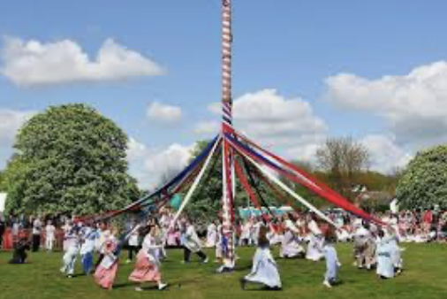
Ist May is a European festival of ancient origins marking the beginning of summer, around halfway between the Spring Equinox and the Summer Solstice. Traditions include gathering green branches and wildflowers which are used to decorate buildings and made into wreaths; crowning a May Queen; setting up a Maypole, around which people dance and sing; as well as parades and processions involving these.

