NOTICES

FAMILY FLOWERS The Family Flower for May has been donated by Shirley Brown in memory of her daughter Sarah and of her Mum and Dad

BIG BREKKIE is back! Breakfast will be served between the 8am and 10am services on Sunday 13th June. Donations will be in aid of Christian Aid.
Please note the change of date.

S^{t} Andrew's Church bank details for one-off payments and gifts -
PCC of St Andrew's Roxbourne Parish
Sort code: 40-11-58 Acc No: 20404810
Please note this is not the account for regular Stewardship Giving - please see Wendy Godwin or Peter Sage for those details (Tel: 07889 249500

Please send any items for next week’s STARLINK to Susan McLeod by midday this Friday, preferably by email (mcleod383@btinternet.com), or otherwise by hard copy to 8, Drake Road.

S^{T} ANDREW'S CHURCH, ROXBOURNE
89 Malvern Avenue Harrow HA2 9ER.
020 8422 3633 www.standrewsroxbourne.org.uk
Registered Charity No. 1131727

Star Link

SUNDAY, 16th May 2021 EASTER 7
Happy Easter The Lord is risen Alleluia

 |  |  | Roxbournestandrews
8.00 am: Holy Communion
10.00 am: Parish Communion
and Go Mad on Sunday

This Week’s Services |  | Next Sunday 23rd May
Monday – Friday  9.00 am Morning Prayer [cw]  Wednesday: 9.30am Holy Communion |  | 8.00 am: Holy Communion  10.00 am: Parish Communion  Ezekiel 36: 24-28; Acts 1: 15-17 & 21-26;  John 17: 6-19

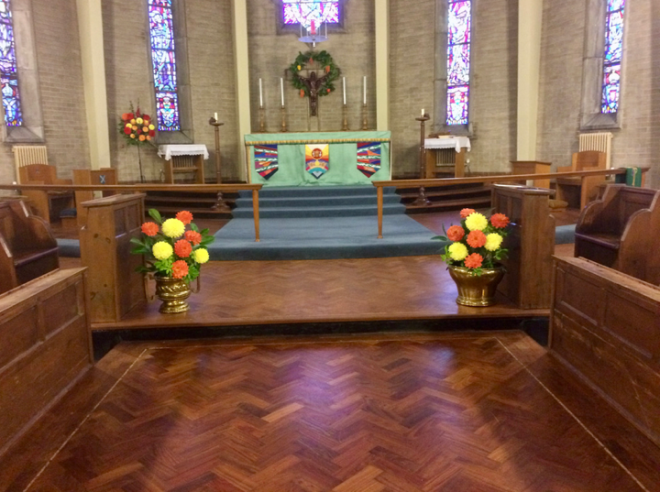
TODAY’S COLLECT

Risen ascended Lord, as we rejoice at your triumph, fill your Church on earth with power and compassion, that all who are estranged by sin may find forgiveness and know your peace, to the glory of God the Father.

TODAY’S READINGS

Ezekiel 36: 24-28
“‘For I will take you out of the nations; I will gather you from all the countries and bring you back into your own land. I will sprinkle clean water on you, and you will be clean; I will cleanse you from all your impurities and from all your idols. I will give you a new heart and put a new spirit in you; I will remove from you your heart of stone and give you a heart of flesh. And I will put my Spirit in you and move you to follow my decrees and be careful to keep my laws. Then you will live in the land I gave your ancestors; you will be my people, and I will be your God.

Romans 12

See separate sheet

John 17: 6-19
“I have revealed you^{[a]} to those whom you gave me out of the world. They were yours; you gave them to me and they have obeyed your word. Now they know that everything you have given me comes from you. For I gave them the words you gave me and they accepted them. They knew with certainty that I came from you, and they believed that you sent me. I pray for them. I am not praying for the world, but for those you have given me, for they are yours. All I have is yours, and all you have is mine. And glory has come to me through them. I will remain in the world no longer, but they are still in the world, and I am coming to you. Holy Father, protect them by the power of your name, the name you gave me, so that they may be one as we are one. While I was with them, I protected them and kept them safe by that name you gave me. None has been lost except the one doomed to destruction so that Scripture would be fulfilled. “I am coming to you now, but I say these things while I am still in the world, so that they may have the full measure of my joy within them. I have given them your word and the world has hated them, for they are not of the world any more than I am of the world. My prayer is not that you take them out of the world but that you protect them from the evil one. They are not of the world, even as I am not of it. Sanctify them by the truth; your word is truth. As you sent me into the world, I have sent them into the world. For them I sanctify myself, that they too may be truly sanctified.

Post-Communion Prayer

Eternal God, giver of love and power, your Son Jesus Christ has sent us into all the world to preach the gospel of his kingdom: confirm us in this mission, and help us to live the good news we proclaim; through Jesus Christ our Lord. Amen

PRAYER DIARY
RIP Anthony Charles Martin Racher, Andy Wray who have recently died

We remember with thanksgiving the anniversaries of: Peter Oxenham; Edith Simpson; Kris Narayan (16th); Amy Woodward (20th); David Keogh (21st); Jessie Hodgson (22nd).

Prayer requested for healing and other needs: Ralph Bedford; Dorothy Dowse; Stuart Hobbs; Pearl Marcano; Jean Murch; Marion Perry; Andrew Phelps; Pam Storey; Michael Scott-Kerr; Elizabeth Tinsey; Avice Wright.

Happy Birthday to: Joyce Nickolay; Mya Edwards-Campbell (16th); Mide Adebombo; Rowen Rawat; (18th).

Church Families: Annie and Andy Dawson; Dorothy Dowse; Patricia Ekanem; Mark and Shelley Ellerbeck; Carole Evans.

The Parish Exeter Road; Field End Road; Hamilton Close; Harlech Gardens; High Worple; Hodson Close; Holyrood Avenue; Ivy Close; Kenilworth Avenue.

The Persecuted Church: Iran The secret police wanted names. Taher wouldn’t give them. Taher and his family were secret believers in a closed country in the Middle East. When their faith was discovered, Taher was arrested and ruthlessly interrogated by the secret police - but he refused to give up the names of fellow believers.
R

PRAYER OF THE WEEK

Dear Jesus, I thank you that you came in human form and lived on earth. You always did what your Heavenly Father desired. Today we celebrate the day when you left the earth by being taken up into Heaven, where you sit on the throne. I remember and believe you will fulfil your promises to us. So I wait for your return to the earth, when sin and death will finally be defeated. Jesus, I need your presence in my life, your direction and help. I pray in the name of Jesus, our Ascended Lord. Amen.

