**NOTICES**

**FLOWERS** The Family flower in St. Stephen’s Chapel for **August** has been given by Sue Brown in loving memory of her mum, Kathleen Taylor,

**AUGUST** There will be no **8am services** throughout the month of **August.**

There will be no **Wednesday services** in **August.**

There will be no **Children’s Church** in **August.**

We all deserve a break and will return in September with renewed energy.

**QUIZ EVENING** Come to our next social event, the Quiz Evening on **Saturday 4th October**. Bring a team or just turn up and join one. They are always good fun.

**HARROW FOOD BANK CONTAINER:** Is still in operation. Please give your contributions to Lyndon, Enid or David. You may also leave it in a bag at the back of the church. We will store it away daily until collection day. We have a small problem which we are trying to address.  *David Alleyne*

**ST. PAUL’S CATHEDRAL** Why not go up to town and pay a visit to St. Paul’s Cathedral? We have 4 free entry cards which can be used at any time. See me and I will pass them to you, but do remember to return them for the next person to use

*Susan McLeod*

***Apology from editor****: John Bedford died in July not August. Paul Hart.*

1. St Andrew's Church bank details for one-off payments and gifts -
2. **PCC of St Andrew's Roxbourne Parish**
3. **Sort code: 40-11-58  Acc No: 20404810**
4. *Please note this is not the account for regular Stewardship Giving - please see Wendy Godwin or Peter Sage for those details (Tel: 07889 249500*

**ST ANDREW'S CHURCH, ROXBOURNE**

|  |  |  |
| --- | --- | --- |
| *STAR LOGO 4* | **89 Malvern Avenue Harrow HA2 9ER.**  **020 8422 3633 www.standrewsroxbourne.org.uk**  **Registered Charity No. 1131727** |  |

***Star Link***

|  |  |  |  |
| --- | --- | --- | --- |
|  | | | |
| **SUNDAY, 17th AUGUST TRINITY 9**  **Welcome to Rev Jane Morris, today’s celebrant** | | | |
|  | | | Roxbournestandrews |
|  | | |
|  | | |
| **10.00 am: Parish Communion**  **with Prayers for Healing**  *Please come to the Hall after the Service for Coffee, Tea & Fellowship* | | |
| **This Week’s Services** |  | **Next Sunday 24th August** | |
| **Monday – Friday 9am Morning Prayer** |  | **10.00 am: Parish Communion**  *Isaiah 43: 8-13; Acts 5: 12-16; Luke 22: 24-30* | |
|  |

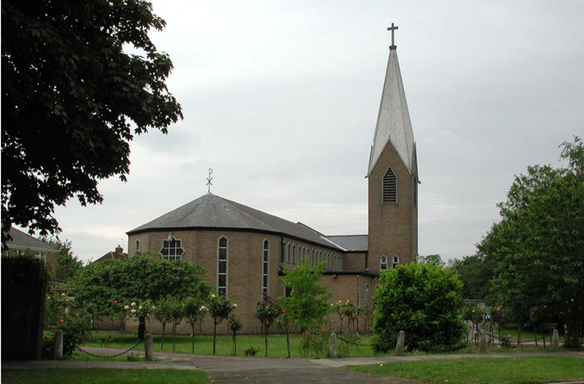

TODAY’S COLLECT

**Gracious Father, revive your Church in our day, and make her holy, strong and faithful, for your glory’s sake in Jesus Christ our Lord. Amen**

TODAY’S READINGS

***Isaiah 5: 1-7***

I will sing for the one I love a song about his vineyard: My loved one had a vineyard on a fertile hillside.He dug it up and cleared it of stones and planted it with the choicest vines. He built a watchtower in it and cut out a winepress as well. Then he looked for a crop of good grapes, but it yielded only bad fruit.“Now you dwellers in Jerusalem and people of Judah, judge between me and my vineyard.What more could have been done for my vineyard than I have done for it? When I looked for good grapes, why did it yield only bad?Now I will tell you what I am going to do to my vineyard: I will take away its hedge, and it will be destroyed; I will break down its wall, and it will be trampled.I will make it a wasteland, neither pruned nor cultivated, and briers and thorns will grow there. I will command the clouds not to rain on it.”The vineyard of the Lord Almighty is the nation of Israel, and the people of Judah are the vines he delighted in. And he looked for justice, but saw bloodshed; for righteousness, but heard cries of distress.

***Hebrews 11: 29-ch.12:2***

By faith the people passed through the Red Sea as on dry land; but when the Egyptians tried to do so, they were drowned.By faith the walls of Jericho fell, after the army had marched around them for seven days.By faith the prostitute Rahab, because she welcomed the spies, was not killed with those who were disobedient. And what more shall I say? I do not have time to tell about Gideon, Barak, Samson and Jephthah, about David and Samuel and the prophets,who through faith conquered kingdoms, administered justice, and gained what was promised; who shut the mouths of lions, quenched the fury of the flames, and escaped the edge of the sword; whose weakness was turned to strength; and who became powerful in battle and routed foreign armies. Women received back their dead, raised to life again. There were others who were tortured, refusing to be released so that they might gain an even better resurrection. Some faced jeers and flogging, and even chains and imprisonment. They were put to death by stoning; they were sawed in two; they were killed by the sword. They went about in sheepskins and goatskins, destitute, persecuted and mistreated— the world was not worthy of them. They wandered in deserts and mountains, living in caves and in holes in the ground.These were all commended for their faith, yet none of them received what had been promised, since God had planned something better for us so that only together with us would they be made perfect. Therefore, since we are surrounded by such a great cloud of witnesses, let us throw off everything that hinders and the sin that so easily entangles. And let us run with perseverance the race marked out for us, fixing our eyes on Jesus, the pioneer and perfecter of faith. For the joy set before him he endured the cross, scorning its shame, and sat down at the right hand of the throne of God

***Luke 12: 49-56***

‘I came to bring fire to the earth, and how I wish it were already kindled! I have a baptism with which to be baptized, and what stress I am under until it is completed! Do you think that I have come to bring peace to the earth? No, I tell you, but rather division! From now on, five in one household will be divided, three against two and two against three; they will be divided: father against son and son against father, mother against daughter and daughter against mother, mother-in-law against her daughter-in-law and daughter-in-law against mother-in-law.’He also said to the crowds, ‘When you see a cloud rising in the west, you immediately say, “It is going to rain”; and so it happens. And when you see the south wind blowing, you say, “There will be scorching heat”; and it happens. You hypocrites! You know how to interpret the appearance of earth and sky, but why do you not know how to interpret the present time?

**POST COMMUNION PRAYER**

**Holy Father, who gathered us here around the table of your Son to share this meal with the whole household of God: in that new world where you reveal the fullness of your peace, gather people of every race and language to share in the eternal banquet of Jesus Christ our Lord. Amen**

**PRAYER DIARY**

**The Parish:** Rowe Walk, Somervell Road, Spinnells Road, Sterling Avenue, Stiven Crescent, Stradbrook Close, Stuart Avenue, The Bungalows, Thistledene Avenue.

**Happy Birthday to:** John Bidder, Alison Coe (17th), Simon McIntyre, Riley Bortey (20th), Vasanthy Gnanarj (23rd).

**This week we remember with thanksgiving the anniversaries of:** Michael Price (19th), Andrea B Rose (22nd), Fr. Edward Nadkarni (23rd).

**Prayer request for healing and other needs** Earl Adams, David Alleyne, Ralph Bedford, Mark Gardiner, Malcolm George, Broden Kelly, Emily Rockingham, Pam Storey, Martin Vowles, Angela Zadurian.

**Church Families:** Les & Maureen Pattison, Alexandra, Michael & Sonia Purice, Rebecca Pennells, Mahender, Roween, Roham & Mol Rawat, Jonathan, Francesca & Vicky Roast, Jennifer Rothwell, Doohyun Ryou Raj & Bernadetta Rajan, Martin, Virgin Flower Leon.

**PRAYER FOR THIS WEEK**

Grant to us, Lord, we beseech thee, the sprit to think and do always such things as to be rightful, that we who cannot do anything that is good without thee, may by thee be enabled to live according to thy will, through Jesus Christ our Lord, Amen.