NOTICES

FLOWERS The Family flower for November in St. Stephen’s Chapel is in memory of of Barbara Wood.

DISCIPLESHIP CLASS This is a new class on Sunday Mornings 9am until 9.45am for those who would like to grow in their walk with God. See Lyndon or Sue Broatch for details.

BARBARA WOOD Barbara was a well loved founding member of St Andrew’s and worshipped here every Sunday for over 60 years until she was forced to move through ill health. Her Memorial Service will take place at 12.30pm on Tuesday 4th November here at St. Andrew’s.

FIREWORK DISPLAY Support our Scouts’ Bonfire night and Firework Display taking place here on our field on Wednesday 5th November. Gates open at 6.30, food and drinks available.

BAPTISM Our next Baptism will be on the 30th November, when we will also be welcoming some children for their First Communion. If you would like to be baptised, please see Lyndon.

HARVEST CHARITY This year we supported the Leprosy Mission and raised a total of £2133.50. Thank you everyone.

REMEMBRANCE SUNDAY is on Sunday 9th November when we remember those who died in the two World Wars and all the conflicts that have taken place since.

CHRISTMAS MARKET is on Saturday 22nd November, 11am to 3pm. ONLY 3 WEEKS TO GO ST ANDREW’S NEEDS YOU!
Could you please sort out any: unwanted presents, in date toiletries and bottles, Christmas decorations, children's toys and books, handbags and scarves, mugs, wrapped sweets. Offers of soup for the Refreshments to Judi and items for the Hamper to Susan. Please put any items in the box at the back of the church.
Please sign up for a stall you would like to run or help with. If you have any ideas for more stalls please sign on the sheet at the back of the church.
Thank you Social Committee

S^{t} Andrew's Church bank details for one-off payments and gifts -
PCC of St Andrew's Roxbourne Parish
Sort code: 40-11-58 Acc No: 20404810
Please note this is not the account for regular Stewardship Giving - please see Wendy Godwin or Peter Sage for those details (Tel: 07889 249500

S^{T} ANDREW'S CHURCH, ROXBOURNE
 | 89 Malvern Avenue Harrow HA2 9ER.  020 8422 3633 www.standrewsroxbourne.org.uk  Registered Charity No. 1131727 | 

Star Link

SUNDAY, 2nd NOVEMBER All Saints and All Souls
Roxbournestandrews



8.00 am: Holy Communion
10.00 am: Parish Communion
with Prayers for Healing
and Children’s Church
Please come to the Hall after the Service for Coffee, Tea & Fellowship

This Week’s Services |  | Next Sunday 9th November
Monday – Friday 9am Morning Prayer  Wednesday 9.30 Communion |  | 8.00 am: Holy Communion  10.00 am: Parish Communion  Ecclesiastes 3: 1-8; 1 Peter 2: 13-25; John 15: 1-13
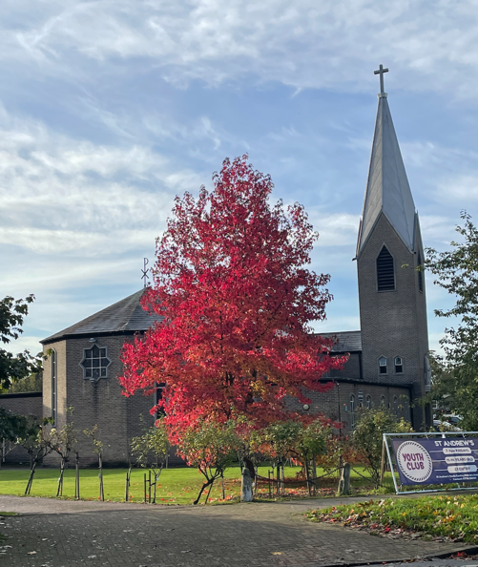

TODAY’S COLLECT
God of holiness your glory is proclaimed in every age as we rejoice in the faith of your saints inspire us to follow their example with boldness and joy through Jesus Christ our Lord. Amen

HALLOWEEN, ALL SAINTS’ DAY AND ALL SOULS’ DAY

Halloween, All Saints’ Day and All Souls’ Day fall between 31st October and 2nd November and their names are all Christian in origin. While Halloween has taken on a cultural and commercial life of its own in recent years, in the past All Saints’ Day and All Souls’ Day were much more important.

How were the three Christian festivals celebrated in the past?

Halloween
Halloween, or All Hallows' Eve, takes its name from the Feast of All Saints’ Day, which later became known as All Hallows. All Hallows' Eve was quite literally the eve before the holy day. However, like today, Halloween was also associated with misbehaviour, and was sometimes called Mischief Night.

All Saints' Day

Christians have honoured their dead since the early days of the church, and there are records of this from at least the 4th century. All Saints’ Day was originally a commemoration of martyrs, people who died for their faith, but was later expanded to include all saints, as the name suggests. Originally a spring festival, in the 8th century, Pope Gregory III moved All Saints’ Day to 1 November to mark the papal dedication of a chapel honouring all saints in St Peter’s Basilica, Rome.
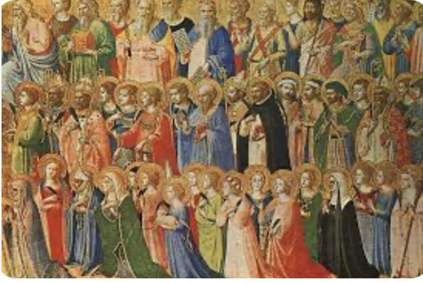

All Souls' Day

The most recent addition to these three feast days, All Souls’ Day, was first celebrated in 11th century. After the Reformation, All Souls’ Day was removed by Protestants, who believed that after death, souls either went straight to heaven or to hell. But in 1928, All Souls’ Day was reinstated into the Church of England calendar: It had an awful lot to do with the terrible slaughter that took place between 1914 and 1918.

Commemoration was very much in people's minds in the aftermath of World War I.
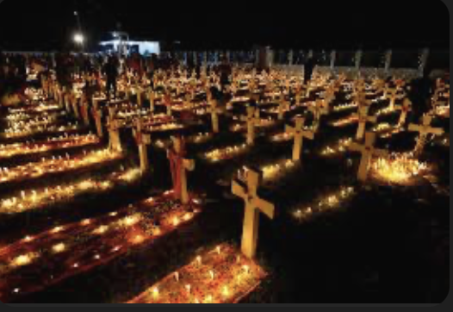
POST-COMMUNION PRAYER

God, the source of all holiness and giver of all good things: may we who have shared at this table as strangers and pilgrims here on earth be welcomed with all your saints to the heavenly feast on the day of your kingdom; through Jesus Christ our Lord. Amen

PRAYER DIARY

R.I.P.: Julie Gilmore who died yesterday

The Parish: Tithe Farm Avenue; Tithe Farm Close; Torbay Road; Tresco Gardens; Veldene Way; Walton Avenue; Walton Crescent; Warden Avenue; Warden Court

Happy Birthday to: Gary Williams (3rd); Mol Rawat (7th); Chanirn Mirando (8th).

This week we remember with thanksgiving the anniversaries of: Daphne Nadkarni (2nd); Robert Clench (3rd); William Brennand (8th).

Prayer request for healing and other needs Earl Adams; Malcolm George; Melaine Louise; Emily Rockingham; Pam Storey; Martin Vowles; Angela Zadurian.

Church Families: Kemi and Ayo Aina; David, Andrea, Robert and Angela Alleyne; Ola & Dami Amode; Bukky & Tobiloba Adereti, Deke & Mide Adebambo.

PRAYER FOR TODAY

Eternal rest grant unto them, O Lord, and let perpetual light shine upon them. May their souls and all the souls of the faithful departed, through the mercy of God, rest in peace. Amen.

