NOTICES

FLOWERS The Family flower for November in St. Stephen’s Chapel is in memory of Barbara Wood

BAPTISM Our next Baptism will be next week on the 30th November, when we will also be welcoming some children for their First Communion.

CHURCH HALL BOOKINGS IN 2026 FOR CHURCH EVENTS Please let me know the dates I should reserve for church events as I have started taking bookings and answering availability enquiries for 2026. You may send text to 075 7878 9099 or email starlet3633@gmail.com Martin (Hall Lettings Secretary)

CHRISTMAS SERVICES
Saturday 20th Dec Carol Service 7pm
Christmas Eve Holy Communion 10am
Crib Service and Christingle 5pm
Midnight Mass 11.30pm
Christmas Day Family Service 10am

CHRISTMAS MARKET Thanks to all those who contributed to and helped with our Christmas Market. Next week we will be able to tell you how much we made. Watch this space!
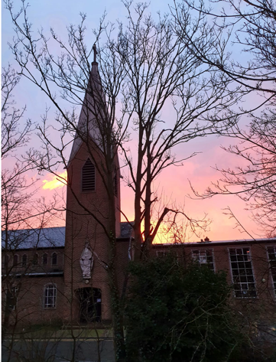

ST. ANDREW’S DAY
is next Sunday, 30th November. Stay after the 10am service to celebrate St. Andrew and our newly baptised members.

S^{t} Andrew's Church bank details for one-off payments and gifts -
PCC of St Andrew's Roxbourne Parish
Sort code: 40-11-58 Acc No: 20404810
Please note this is not the account for regular Stewardship Giving - please see Wendy Godwin or Peter Sage for those details (Tel: 07889 249500
S^{T} ANDREW'S CHURCH, ROXBOURNE
 | 89 Malvern Avenue Harrow HA2 9ER.  020 8422 3633 www.standrewsroxbourne.org.uk  Registered Charity No. 1131727 | 

Star Link

SUNDAY, 23rd NOVEMBER 2025 CHRIST THE KING

Roxbournestandrews



8.00 am: Holy Communion
10.00 am: Parish Communion
with Prayers for Healing
and Children’s Church
Please come to the Hall after the Service for Coffee, Tea & Fellowship

This Week’s Services |  | Next Sunday 30th November
Monday – Friday  9.00 am Morning Prayer [cw]  Wednesday: 9.30am Holy Communion |  | 8.00 am: Holy Communion  10.00 am: Parish Communion  Daniel 7: 9-10 & 13-14; Revelation 1: 4b-8;  John 18: 33-37

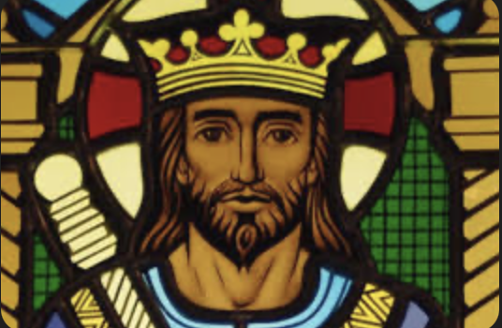

TODAY’S COLLECT

God the Father, help us to hear the call of Christ the King and to follow in his service, whose kingdom has no end; for he reigns with you and the Holy Spirit, one God, one glory. Amen

TODAY’S READINGS

Jeremiah 23: 1-6
‘Woe to the shepherds who are destroying and scattering the sheep of my pasture!’ declares the Lord. Therefore this is what the Lord, the God of Israel, says to the shepherds who tend my people: ‘Because you have scattered my flock and driven them away and have not bestowed care on them, I will bestow punishment on you for the evil you have done,’ declares the Lord. ‘I myself will gather the remnant of my flock out of all the countries where I have driven them and will bring them back to their pasture, where they will be fruitful and increase in number. I will place shepherds over them who will tend them, and they will no longer be afraid or terrified, nor will any be missing,’ declares the Lord. ‘The days are coming,’ declares the Lord, ‘when I will raise up for David a righteous branch, a King who will reign wisely and do what is just and right in the land. In his days Judah will be saved and Israel will live in safety. This is the name by which he will be called: The Lord Our Righteous Saviour.

Colossians 1: 11-20
being strengthened with all power according to his glorious might so that you may have great endurance and patience, and giving joyful thanks to the Father, who has qualified you to share in the inheritance of his holy people in the kingdom of light. For he has rescued us from the dominion of darkness and brought us into the kingdom of the Son he loves, in whom we have redemption, the forgiveness of sins. The Son is the image of the invisible God, the firstborn over all creation. For in him all things were created: things in heaven and on earth, visible and invisible, whether thrones or powers or rulers or authorities; all things have been created through him and for him. He is before all things, and in him all things hold together. And he is the head of the body, the church; he is the beginning and the firstborn from among the dead, so that in everything he might have the supremacy. For God was pleased to have all his fullness dwell in him, and through him to reconcile to himself all things, whether things on earth or things in heaven, by making peace through his blood, shed on the cross.

Luke 23: 33-43
When they came to the place that is called The Skull, they crucified Jesus there with the criminals, one on his right and one on his left. Then Jesus said, ‘Father, forgive them; for they do not know what they are doing.’ And they cast lots to divide his clothing. And the people stood by, watching; but the leaders scoffed at him, saying, ‘He saved others; let him save himself if he is the Messiah of God, his chosen one!’ The soldiers also mocked him, coming up and offering him sour wine, and saying, ‘If you are the King of the Jews, save yourself!’ There was also an inscription over him, ‘This is the King of the Jews.’ One of the criminals who were hanged there kept deriding him and saying, ‘Are you not the Messiah? Save yourself and us!’ But the other rebuked him, saying, ‘Do you not fear God, since you are under the same sentence of condemnation? And we indeed have been condemned justly, for we are getting what we deserve for our deeds, but this man has done nothing wrong.’ Then he said, ‘Jesus, remember me when you come into your kingdom.’ He replied, ‘Truly I tell you, today you will be with me in Paradise.’

POST COMMUNION PRAYER

Stir up, O Lord, the wills of your faithful people; that they, plenteously bringing forth the fruit of good works, may by you be plenteously rewarded; through Jesus Christ our Lord. Amen

PRAYER DIARY

The Parish: Our School Groups: Alexandra Special; Heathland; Moriah Jewish; Newton Farm; Roxbourne; Rooks Heath; Roxeth Free Church; South Harrow Baptist.

Happy Birthday to: Marita Brown (22nd); Susan Broatch (24th); Wendy Godwin; Alan Heyes (25th); Leah Gordon (26th); Shirley Brown (29th).

This week we remember with thanksgiving the anniversaries of: Gerald Woodward (23rd); Ronnie Craft (24th); Donald Bowell (29th).

Prayer request for healing and other needs: Earl Adams; Malcolm George;.Emily Rockingham; Pam Storey; Martin Vowles; Angela Zadurian.

Church Families: Vincento Carrara; John and Rose Chamberlain ; Danny, Sherin and Suja Chandran; Ann-Marie Cunyngham; Robert Crowhurst.

PRAYER FOR THE WEEK

Eternal Father, whose Son Jesus Christ ascended to the throne of heaven that he might rule over all things as Lord and King: keep the Church in the unity of the Spirit and in the bond of peace, and bring the whole created order to worship at his feet. Amen.

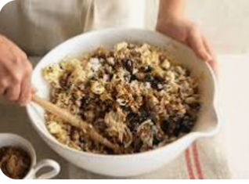
Stir-up Sunday is the last Sunday before Advent and a classic festive tradition that dates back to Victorian times. It's the day families gather to mix and stir their Christmas pudding, giving it time to mature before the big day. Everyone takes a turn to stir the mixture, and make a wish while they do. The name comes from the Anglican prayer that begins with the words, "Stir up, we beseech thee, O Lord," as can be seen above.

