NOTICES


CHRISTMAS CHARITY This year the chosen charity we are supporting is St Mungo’s, a charity helping homeless people. Envelopes for donations are in the pews. All donations warmly accepted.


ANGEL TREE Prison Fellowship is a charity which aims to share the Gospel with prisoners in the UK. ANGEL TREE arranges for Christmas presents to be sent to the children of prisoners on behalf of the prisoner. For a number of years now, members of our Congregation have contributed to this charity by buying a present (suggested by the prisoner), or making a donation to help with the cost of postage. Envelopes are available on the Sidespersons table. If you want to know more about this charity do speak to me. Keith Nicholls

CHRISTMAS SERVICES Do join us over Christmas at our special services.
Saturday 20th Dec 7pm Carol Service
Christmas Eve 10.00 am Parish Communion
5.00 pm Crib Service and Christingle
11.30 pm Midnight Mass
Christmas Day 10.00 am Family Christmas Service

MESSY CHURCH Many thanks to all who helped in yesterday’s Messy Church and made it such a success. Gill Moore

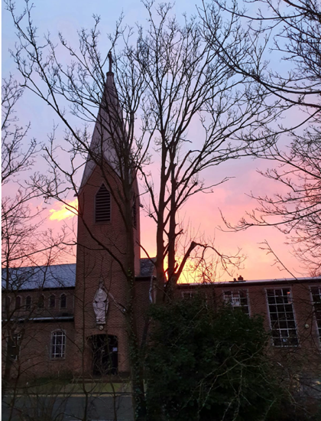

OPEN HOUSE CHRISTMAS AT THE VICARAGE. 7.30pm 17th December.
Drinks, Carols and Nibbles. Please join us.

S^{T} ANDREW'S CHURCH, ROXBOURNE
 | 89 Malvern Avenue Harrow HA2 9ER.  020 8422 3633 www.standrewsroxbourne.org.uk  Registered Charity No. 1131727 | 

Star Link

SUNDAY, 14th DECEMBER 2025 ADVENT 3

Roxbournestandrews



8.00 am: Holy Communion
10.00 am: Parish Communion
with Prayers for Healing
and Children’s Church
Please come to the Hall after the Service for Coffee, Tea & Fellowship

This Week’s Services |  | Next Sunday 21st December
Monday – Friday  9.00 am Morning Prayer [cw]  Wednesday: 9.30am Holy Communion |  | 8.00 am: Holy Communion  10.00 am: Parish Communion  Isaiah 7.10-16; Romans1.1-7; Matthew 1.18-25

TODAY’S COLLECT

God for whom we watch and wait, you sent John the Baptist to prepare the way of your Son: give us courage to speak the truth, to hunger for justice, and to suffer for the cause of right, with Jesus Christ our Lord. Amen
TODAY’S READINGS

Isaiah 35.1-10
The desert and the parched land will be glad; the wilderness will rejoice and blossom. Like the crocus, it will burst into bloom; it will rejoice greatly and shout for joy. The glory of Lebanon will be given to it, the splendour of Carmel and Sharon; they will see the glory of the Lord, the splendour of our God. Strengthen the feeble hands, steady the knees that give way; say to those with fearful hearts, ‘Be strong, do not fear; your God will come, he will come with vengeance; with divine retribution he will come to save you.’ Then will the eyes of the blind be opened and the ears of the deaf unstopped. Then will the lame leap like a deer, and the mute tongue shout for joy. Water will gush forth in the wilderness and streams in the desert. The burning sand will become a pool, the thirsty ground bubbling springs. In the haunts where jackals once lay, grass and reeds and papyrus will grow. And a highway will be there; it will be called the Way of Holiness; it will be for those who walk on that Way. The unclean will not journey on it; wicked fools will not go about on it. No lion will be there, nor any ravenous beast; they will not be found there. But only the redeemed will walk there, and those the Lord has rescued will return. They will enter Zion with singing; everlasting joy will crown their heads. Gladness and joy will overtake them, and sorrow and sighing will flee away.

James 5.7-10
Be patient, then, brothers and sisters, until the Lord’s coming. See how the farmer waits for the land to yield its valuable crop, patiently waiting for the autumn and spring rains. You too, be patient and stand firm, because the Lord’s coming is near. Don’t grumble against one another, brothers and sisters, or you will be judged. The Judge is standing at the door! Brothers and sisters, as an example of patience in the face of suffering, take the prophets who spoke in the name of the Lord.

Matthew 11.2-11
Then he looked up at his disciples and said: ‘Blessed are you who are poor, for yours is the kingdom of God. ‘Blessed are you who are hungry now, for you will be filled. ‘Blessed are you who weep now, for you will laugh. ‘Blessed are you when people hate you, and when they exclude you, revile you, and defame you on account of the Son of Man. Rejoice on that day and leap for joy, for surely your reward is great in heaven; for that is what their ancestors did to the prophets. ‘But woe to you who are rich, for you have received your consolation. ‘Woe to you who are full now, for you will be hungry. ‘Woe to you who are laughing now, for you will mourn and weep. ‘Woe to you when all speak well of you, for that is what their ancestors did to the false prophets. ‘But I say to you that listen, Love your enemies, do good to those who hate you, bless those who curse you, pray for those who abuse you. If anyone strikes you on the cheek, offer the other also; and from anyone who takes away your coat do not withhold even your shirt. Give to everyone who begs from you; and if anyone takes away your goods, do not ask for them again. Do to others as you would have them do to you.

POST-COMMUNION PRAYER

We give you thanks, O Lord, for these heavenly gifts; kindle in us the fire of your Spirit that when your Christ comes again we may shine as lights before his face; who is alive and reigns now and for ever. Amen

PRAYER DIARY

The Parish: Holyrood Avenue; Ivy Close; Kenilworth Avenue; Kings Court; Kings Road; Leamington Crescent; Lulworth Close; Lulworth Gardens; Lynton Road.

Happy Birthday to: John Chamberlain (16th); Angela Wilson; Kil Boon Kwon (17th); Ava James; Mia – Rose Wright (18th).

This week we remember with thanksgiving the anniversaries of: Alfred Shadbolt (14th); Max Nauta (18th); Vernal Lewis; Francis Pay; Ada Pay; Stuart Hobbs (19th).

Prayer request for healing and other needs: Earl Adams; Michael Donnellan; Lenore Marcano – Green; Noel; Steven; Elizabeth Francis. Malcolm George; Emily Rockingham; Pam Storey; Martin Vowles; David Udall; Angela Zadurian.

Church Families: Solomon, Vasanthy, Samuel and Angeline Gnanaraj; Malcolm George; Sheelagh Gillard; Wendy Godwin; Colin and Andrea Gordon; Marva Greyson; Dominique, Daniel and Danny Thompson; Geoffrey, Keira and Judith Grice; Ashish; Ariham; Audvik and Nidi Gupta.

PRAYER FOR THE WEEK

"Rejoice" (Gaudete Sunday) Let us focus on the joy of the coming Christ, asking God to fill us with hope, light, and peace, enabling us to be witnesses of His love and bring comfort to others, even amidst sorrow, as we await the fulfilment of His promises through Jesus

