NOTICES

LENT APPEAL Wow! We raised over £2000 for Toilet twinning, our Lent charity. That means we can twin all the toilets here at St. Andrew’s and more. Each of our toilets will get a certificate stating where the latrine is with which it is twinned and a photo too. Well done everybody.

NEW: DEEPER IN FAITH WOMEN’S GROUP A space to slow down, reflect, and grow deeper in faith together through Bible study and friendship on Thursday evening 7.30-9.30pm monthly starting 7th May in the Vicarage. Please speak to Irene Teo or Barbara North


CHRISTIAN AID BIG BREKKIE
Join us on Sunday 11th May from 8.45 – 9.45.
Hot and cold items available, all your favourites!
All donations to Christian Aid.

HARROW FOOD BANK There is a box at the back of the church for donations. It is taken every month to Harrow Food Bank; let’s see if we can beat last month’s total.

bank details for one-off payments and gifts -
PCC of St Andrew's Roxbourne Parish
Sort code: 40-11-58 Acc No: 20404810
Please note this is not the account for regular Stewardship Giving - please see Wendy Godwin or Peter Sage for those details (Tel: 07889 249500)

PRAYER FOR TODAY
Good Shepherd, watch over us today in all we face and experience. Never leave us or forsake us and journey with us always.

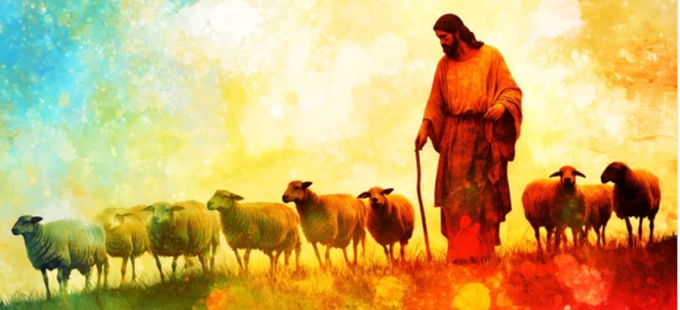
S^{T} ANDREW'S CHURCH, ROXBOURNE
 | 89 Malvern Avenue Harrow HA2 9ER.  020 8422 3633 www.standrewsroxbourne.org.uk  Registered Charity No. 1131727 | 

Star Link

SUNDAY, 26th APRIL EASTER 4
Welcome to Rev. David Tuck, today’s celebrant
Roxbournestandrews



8.00 am: Holy Communion
10.00 am: Parish Communion
and Children’s Church
Please come to the Hall after the Service for Coffee, Tea & Fellowship

This Week’s Services |  | Next Sunday 3rd May
Monday – Friday 9am Morning Prayer  Wednesday 9.30 Communion |  | 8.00 am: Holy Communion  10.00 am: Parish Communion  Genesis 8: 1-19; Acts 7: 55-60; John 14: 1-14
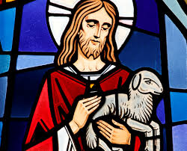
TODAY’S COLLECT

Risen Christ, faithful shepherd of your Father’s sheep: teach us to hear your voice and to follow your command, that all your people may be gathered into one flock, to the glory of God the Father. Amen

TODAY’S READINGS

Genesis ch.7
The Lord then said to Noah, “Go into the ark, you and your whole family, because I have found you righteous in this generation. Take with you seven pairs of every kind of clean animal, a male and its mate, and one pair of every kind of unclean animal, a male and its mate, and also seven pairs of every kind of bird, male and female, to keep their various kinds alive throughout the earth. Seven days from now I will send rain on the earth for forty days and forty nights, and I will wipe from the face of the earth every living creature I have made.” And Noah did all that the Lord commanded him. Noah was six hundred years old when the floodwaters came on the earth. And Noah and his sons and his wife and his sons’ wives entered the ark to escape the waters of the flood. Pairs of clean and unclean animals, of birds and of all creatures that move along the ground, male and female, came to Noah and entered the ark, as God had commanded Noah. And after the seven days the floodwaters came on the earth. In the six hundredth year of Noah’s life, on the seventeenth day of the second month—on that day all the springs of the great deep burst forth, and the floodgates of the heavens were opened. And rain fell on the earth forty days and forty nights. On that very day Noah and his sons, Shem, Ham and Japheth, together with his wife and the wives of his three sons, entered the ark. They had with them every wild animal according to its kind, all livestock according to their kinds, every creature that moves along the ground according to its kind and every bird according to its kind, everything with wings. Pairs of all creatures that have the breath of life in them came to Noah and entered the ark. The animals going in were male and female of every living thing, as God had commanded Noah. Then the Lord shut him in. For forty days the flood kept coming on the earth, and as the waters increased they lifted the ark high above the earth. The waters rose and increased greatly on the earth, and the ark floated on the surface of the water. They rose greatly on the earth, and all the high mountains under the entire heavens were covered. The waters rose and covered the mountains to a depth of more than fifteen cubits. Every living thing that moved on land perished—birds, livestock, wild animals, all the creatures that swarm over the earth, and all mankind. Everything on dry land that had the breath of life in its nostrils died. Every living thing on the face of the earth was wiped out; people and animals and the creatures that move along the ground and the birds were wiped from the earth. Only Noah was left, and those with him in the ark. The waters flooded the earth for a hundred and fifty days.

Acts 2: 42-47
They devoted themselves to the apostles’ teaching and to fellowship, to the breaking of bread and to prayer. Everyone was filled with awe at the many wonders and signs performed by the apostles. All the believers were together and had everything in common. They sold property and possessions to give to anyone who had need. Every day they continued to meet together in the temple courts. They broke bread in their homes and ate together with glad and sincere hearts, praising God and enjoying the favour of all the people. And the Lord added to their number daily those who were being saved.

John 10: 1-10
Very truly, I tell you, anyone who does not enter the sheepfold by the gate but climbs in by another way is a thief and a bandit. The one who enters by the gate is the shepherd of the sheep. The gatekeeper opens the gate for him, and the sheep hear his voice. He calls his own sheep by name and leads them out. When he has brought out all his own, he goes ahead of them, and the sheep follow him because they know his voice. They will not follow a stranger, but they will run from him because they do not know the voice of strangers.’ Jesus used this figure of speech with them, but they did not understand what he was saying to them. So again Jesus said to them, ‘Very truly, I tell you, I am the gate for the sheep. All who came before me are thieves and bandits; but the sheep did not listen to them. I am the gate. Whoever enters by me will be saved, and will come in and go out and find pasture. The thief comes only to steal and kill and destroy. I came that they may have life, and have it abundantly.

POST COMMUNION PRAYER

Merciful Father, you gave your Son Jesus Christ to be the good shepherd, and in his love for us to lay down his life and rise again: keep us always under his protection, and give us grace to follow in his steps; through Jesus Christ our Lord. Amen

PRAYER DIARY

The Parish: Dunster Way; Eastcote Lane; Edinburgh Close; Exeter Road; Field End Road; Hamilton Crescent; Harlech Gardens; High Worple; Hodson Close.

Happy Birthday to: Keith Nicholls (27th); Pauline Harrowell; Christopher Twentyman (1st)

This week we remember with thanksgiving the anniversaries of: Peter Godwin (26th); Eliza Haigh (27th); Peter Dowse (29th); Ethel Williams; Phillip Robinson (30th); Evelyn Roderick (2nd).

Prayer request for healing and other needs: Elizabeth Bello, Sue Broatch, Darrel Campbell, Malcolm George, Joyce Nickolay, Pam Storey, Martin Voles, Clive Williams, Callum Williams, Angela Zadurian.

Church families: Mark and Shelley Ellerbeck; Richard, Candice and Cleo Falconer; Noel, Stephen and Elizabeth Francis.

