NOTICES

WELCOME to Theodore Courtney who is being baptised today, a child of God.

NEW: DEEPER IN FAITH WOMEN’S GROUP A space to slow down, reflect, and grow deeper in faith together through Bible study and friendship on Thursday evenings 7.30-9.30pm every month in the Vicarage. Our first meeting was successful, come and join us next month. Please speak to Irene Teo or Barbara North.

MESSY CHURCH Yesterday’s Messy Church was another successful event bringing local people of all faiths to St Andrew’s. It was based on the story of Jonah.
Gill Moore

CHRISTIAN AID BIG BREKKIE
Many thanks to Rebecca and the team for their hard work cooking our excellent breakfasts. We hope you enjoyed breakfast this morning.
If you missed it you can still donate to Christian Aid at christianaid.org.uk

HARROW FOOD BANK There is a box at the back of the church for donations. It is taken every month to Harrow Food Bank; let’s see if we can beat last month’s total.

NEXT SOCIAL EVENT Please put 28th June in your diaries. We will be having a picnic on the field celebrating Summer.

bank details for one-off payments and gifts -
PCC of St Andrew's Roxbourne Parish
Sort code: 40-11-58 Acc No: 20404810
Please note this is not the account for regular Stewardship Giving - please see Wendy Godwin or Peter Sage for those details (Tel: 07889 249500)

PRAYER FOR TODAY
Make me a tree, Lord,
Sturdy, Deep rooted, Useful,
Support to those in need,
Shelter to those who are weary,
Fruit for those who hunger.
Make me a tree, Lord,
Sturdy, Deep rooted, Useful.
S^{T} ANDREW'S CHURCH, ROXBOURNE
 | 89 Malvern Avenue Harrow HA2 9ER.  020 8422 3633 www.standrewsroxbourne.org.uk  Registered Charity No. 1131727 | 

Star Link

SUNDAY, 10th MAY EASTER 6
Roxbournestandrews



8.00 am: Holy Communion
10.00 am: Parish Communion
and Children’s Church
Please come to the Hall after the Service for Coffee, Tea & Fellowship

This Week’s Services |  | Next Sunday 17th May
Monday – Friday 9am Morning Prayer  Wednesday 9.30 Communion |  | 8.00 am: Holy Communion  10.00 am: Parish Communion  Genesis 8: 1-19; Acts 7: 55-60; John 14: 1-14
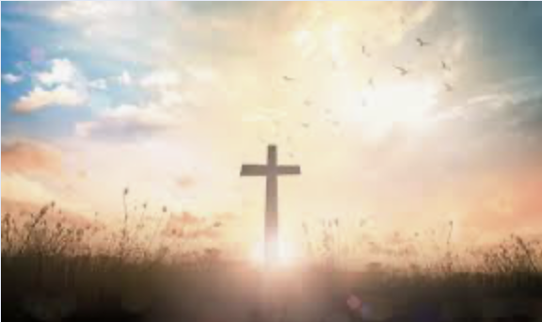

TODAY’S COLLECT

Risen Christ, by the lakeside you renewed your call to your disciples: help your Church to obey your command and draw the nations to the fire of your love, to the glory of God the Father. Amen

TODAY’S READINGS

1 Peter 3.13-22
Who is going to harm you if you are eager to do good? But even if you should suffer for what is right, you are blessed. “Do not fear their threats; do not be frightened.” But in your hearts revere Christ as Lord. Always be prepared to give an answer to everyone who asks you to give the reason for the hope that you have. But do this with gentleness and respect, keeping a clear conscience, so that those who speak maliciously against your good behaviour in Christ may be ashamed of their slander. For it is better, if it is God’s will, to suffer for doing good than for doing evil. For Christ also suffered once for sins, the righteous for the unrighteous, to bring you to God. He was put to death in the body but made alive in the Spirit. After being made alive, he went and made proclamation to the imprisoned spirits— to those who were disobedient long ago when God waited patiently in the days of Noah while the ark was being built. In it only a few people, eight in all, were saved through water, and this water symbolizes baptism that now saves you also—not the removal of dirt from the body but the pledge of a clear conscience toward God. It saves you by the resurrection of Jesus Christ, who has gone into heaven and is at God’s right hand—with angels, authorities and powers in submission to him.

Acts 17.22-31
Paul then stood up in the meeting of the Areopagus and said: “People of Athens! I see that in every way you are very religious. For as I walked around and looked carefully at your objects of worship, I even found an altar with this inscription: to an unknown god. So you are ignorant of the very thing you worship—and this is what I am going to proclaim to you. “The God who made the world and everything in it is the Lord of heaven and earth and does not live in temples built by human hands. And he is not served by human hands, as if he needed anything. Rather, he himself gives everyone life and breath and everything else. From one man he made all the nations, that they should inhabit the whole earth; and he marked out their appointed times in history and the boundaries of their lands. God did this so that they would seek him and perhaps reach out for him and find him, though he is not far from any one of us. ‘For in him we live and move and have our being.’ As some of your own poets have said, ‘We are his offspring.’ “Therefore since we are God’s offspring, we should not think that the divine being is like gold or silver or stone—an image made by human design and skill. In the past God overlooked such ignorance, but now he commands all people everywhere to repent. For he has set a day when he will judge the world with justice by the man he has appointed. He has given proof of this to everyone by raising him from the dead.”

John 14.15-21
‘If you love me, you will keep my commandments. And I will ask the Father, and he will give you another Advocate, to be with you for ever. This is the Spirit of truth, whom the world cannot receive, because it neither sees him nor knows him. You know him, because he abides with you, and he will be in you. ‘I will not leave you orphaned; I am coming to you. In a little while the world will no longer see me, but you will see me; because I live, you also will live. On that day you will know that I am in my Father, and you in me, and I in you. They who have my commandments and keep them are those who love me; and those who love me will be loved by my Father, and I will love them and reveal myself to them.’
POST COMMUNION PRAYER

God our Father, whose Son Jesus Christ gives the water of eternal life: may we thirst for you, the spring of life and source of goodness, through him who is alive and reigns, now and for ever. Amen

PRAYER DIARY

The Parish: Lynwood Close; Malvern Avenue; Meadfield; Merlins Avenue; Minehead Court; Minehead Road; Mirren Close; Newlyn Gardens; Newquay Crescent.

Happy Birthday to: Dorothy Dowse (10th); Ann Varley, Sherin Chandran (14th); Joyce Nickolay (16th).

This week we remember with thanksgiving the anniversaries of: Percy Simpson (13th); Peter Oxenham, Edith Simpson; (16th).

Prayer request for healing and other needs: Ralph Bedford, Elizabeth Bello, Sue Broatch, Malcolm George, Sheelagh Gillard, Joyce Nickolay, Pam Storey, Martin Voles, Gary Williams, Clive Williams, Callum Williams, Angela Zadurian.

Church families: Geoffrey, Keira and Judith Grice; Ashish, Nidi, Ariham and Audvik Gupta.
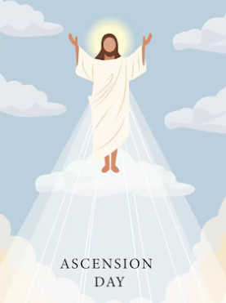
Ascension Day commemorates the last earthly appearance of the Risen Christ. It occurs on the Thursday 40 days after Easter. It marks the end of the Easter season and falls ten days before Pentecost.
According to the accounts in the Gospel of Luke and the Acts of the Apostles, Jesus appeared to many of his disciples during the 40 days following his resurrection to instruct them on how to carry out his teachings. On the 40th day, he came again to the Apostles and led them out to the Mount of Olives where he instructed them to wait in Jerusalem for the promise of the Holy Spirit. Then, as they were watching, he ascended into the clouds.

