NOTICES

ST. STEPHEN’S CHAPEL The Family Flower for May is given by Shirley Brown in Remembrance of The Brown Family.

NEW: DEEPER IN FAITH WOMEN’S GROUP A space to slow down, reflect, and grow deeper in faith together through Bible study and friendship on Thursday evenings 7.30-9.30pm every month in the Vicarage. Our next meeting will be on Thursday 4th June. Please speak to Irene Teo or Barbara North.

KITCHEN APPEAL You will see posters and a flyer you have been given about our Kitchen Appeal. Anyone who has been in our kitchen can see how much it needs improvement. We want to future proof our new kitchen so it is ready for whatever St Andrew’s provides in the future from café style tea and coffee to full meals on a regular or occasional basis. We aim to replace the kitchen in August.

HARROW FOOD BANK There is a box at the back of the church for donations. It is taken every month to Harrow Food Bank; let’s see if we can beat last month’s total.

NEXT SOCIAL EVENT Please put 28th June in your diaries. We will be having a picnic on the field celebrating Summer.

SCOUTS Stay after this morning’s service and support the Scouts who are selling plants and cakes to raise funds for their next adventure.

bank details for one-off payments and gifts -
PCC of St Andrew's Roxbourne Parish
Sort code: 40-11-58 Acc No: 20404810
Please note this is not the account for regular Stewardship Giving - please see Wendy Godwin or Peter Sage for those details (Tel: 07889 249500)

A PRAYER FOR PENTECOST

Spirit of the living God, who rushed like wind and burned like fire, awaken my heart today. Just as you empowered your people at Pentecost, breathe new life into me. Fill my words with truth and kindness. Stir my spirit to speak boldly of your goodness. When I am weary, be my strength. When I am afraid, be my courage. Let your presence dwell in me, shaping how I move through the world. And may my life bear witness to the beautiful, boundary-breaking work you are still doing. Amen.
S^{T} ANDREW'S CHURCH, ROXBOURNE
 | 89 Malvern Avenue Harrow HA2 9ER.  020 8422 3633 www.standrewsroxbourne.org.uk  Registered Charity No. 1131727 | 

Star Link

SUNDAY, 24th MAY PENTECOST
Welcome to Rev David Tuck, today’s celebrant
Roxbournestandrews



8.00 am: Holy Communion
10.00 am: Parish Communion
and Children’s Church
Please come to the Hall after the Service for Coffee, Tea & Fellowship

This Week’s Services |  | Next Sunday 31st May
Monday – Friday 9am Morning Prayer  Wednesday 9.30 Communion |  | 8.00 am: Holy Communion  10.00 am: Parish Communion  Isaiah 40: 12-17 & 27-31; II Corinthians 13: 11-13; Matthew 28: 16-20
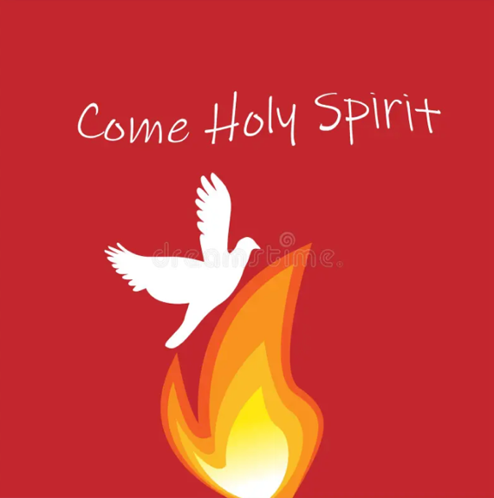

TODAY’S COLLECT

Holy Spirit, sent by the Father, ignite in us your holy fire; strengthen your children with the gift of faith, revive your Church with the breath of love, and renew the face of the earth, through Jesus Christ our Lord. Amen

TODAY’S READINGS

Numbers 11: 24-30
So Moses went out and told the people what the Lord had said. He brought together seventy of their elders and had them stand around the tent. Then the Lord came down in the cloud and spoke with him, and he took some of the power of the Spirit that was on him and put it on the seventy elders. When the Spirit rested on them, they prophesied—but did not do so again. However, two men, whose names were Eldad and Medad, had remained in the camp. They were listed among the elders, but did not go out to the tent. Yet the Spirit also rested on them, and they prophesied in the camp. A young man ran and told Moses, “Eldad and Medad are prophesying in the camp.” Joshua son of Nun, who had been Moses’ aide since youth, spoke up and said, “Moses, my lord, stop them!” But Moses replied, “Are you jealous for my sake? I wish that all the Lord’s people were prophets and that the Lord would put his Spirit on them!” Then Moses and the elders of Israel returned to the camp.

Acts 2: 1-21
When the day of Pentecost came, they were all together in one place. Suddenly a sound like the blowing of a violent wind came from heaven and filled the whole house where they were sitting. They saw what seemed to be tongues of fire that separated and came to rest on each of them. All of them were filled with the Holy Spirit and began to speak in other tongues as the Spirit enabled them. Now there were staying in Jerusalem God-fearing Jews from every nation under heaven. When they heard this sound, a crowd came together in bewilderment, because each one heard their own language being spoken. Utterly amazed, they asked: “Aren’t all these who are speaking Galileans? Then how is it that each of us hears them in our native language? Parthians, Medes and Elamites; residents of Mesopotamia, Judea and Cappadocia, Pontus and Asia, Phrygia and Pamphylia, Egypt and the parts of Libya near Cyrene; visitors from Rome (both Jews and converts to Judaism); Cretans and Arabs—we hear them declaring the wonders of God in our own tongues!” Amazed and perplexed, they asked one another, “What does this mean?” Some, however, made fun of them and said, “They have had too much wine.” Then Peter stood up with the Eleven, raised his voice and addressed the crowd: “Fellow Jews and all of you who live in Jerusalem, let me explain this to you; listen carefully to what I say. These people are not drunk, as you suppose. It’s only nine in the morning! No, this is what was spoken by the prophet Joel: “‘In the last days, God says, I will pour out my Spirit on all people. Your sons and daughters will prophesy, your young men will see visions, your old men will dream dreams. Even on my servants, both men and women, I will pour out my Spirit in those days, and they will prophesy. I will show wonders in the heavens above and signs on the earth below, blood and fire and billows of smoke. The sun will be turned to darkness and the moon to blood before the coming of the great and glorious day of the Lord. And everyone who calls on the name of the Lord will be saved.’

John 7: 37-39
On the last day of the festival, the great day, while Jesus was standing there, he cried out, ‘Let anyone who is thirsty come to me, and let the one who believes in me drink. As the scripture has said, “Out of the believer’s heart shall flow rivers of living water.”’ Now he said this about the Spirit, which believers in him were to receive; for as yet there was no Spirit, because Jesus was not yet glorified.

POST COMMUNION PRAYER

Faithful God, who fulfilled the promises of Easter by sending us your Holy Spirit and opening to every race and nation the way of life eternal: open our lips by your Spirit, that every tongue may tell of your glory; through Jesus Christ our Lord. Amen

PRAYER DIARY

R I. P.: David (Clive) Williams, Gary’s brother who has died in Jamaica.

This week we remember with thanksgiving the anniversaries of: Donald George, Louise Gray (24th); Reginald Williams (26th); Margaret Mason (28th); Bridget Allen (29th).

Prayer request for healing and other needs: Ralph Bedford; Sue Broatch; Elizabeth Bello; Darrell Campbell; Malcolm George; Sheelagh Gillard; Joyce Nickolay; Pam Storey; Martin Voles; Gary Williams; Angela Zadurian.

Happy Birthday to: Yedami Jung; Raj Rajan (26th).

Congratulations to: Douglas and Enid Scott – Kerr who were married on 26th May 1979. May they have a happy day together and many more to follow.

Church families: Isaac Nemo; Hyung Jacobs; Michael, Ava and Stacey James; Michael and Renee Joshua; Sue and Ian Jull; Sunhyun, Gwon and Yedami Jung.

The Parish: Sterling Avenue; Stiven Crescent; Stradbrook Close; Stuart Avenue; The Bungalows; Thistledene Avenue; Tithe Farm Avenue; Tithe Farm Close; Torbay Road.

