NOTICES

ST. STEPHEN’S CHAPEL The Family Flower for June is given by Pam Storey in loving memory of her husband, Michael.

KITCHEN APPEAL You will see posters and a flyer you have been given about our Kitchen Appeal. Anyone who has been in our kitchen can see how much it needs improvement. We want to future proof our new kitchen so it is ready for whatever St Andrew’s provides in the future from café style tea and coffee to full meals on a regular or occasional basis. We aim to replace the kitchen in August. Please give generously.

HARROW FOOD BANK There is a box at the back of the church for donations. It is taken every month to Harrow Food Bank; let’s see if we can beat last month’s total.


SUMMER PICNIC Join us on the field any time after the 10am service on Sunday 28th June on the field. Bring your own food and drink but there will also be burgers you can buy and ice creams if the weather is hot. There will be live music from Groove Alchemy, who will provide a great atmosphere at the picnic, a bouncy castle and a play area for little ones. Just sign up to give us an idea of numbers; the cost will be £2 each.

SOCIAL EVENTS We are planning more Social Events after the School Holidays so watch this space!


MEMORIAL GARDEN All the roses in our garden are in memory of someone loved. Many thanks to those who tend our garden and keep our roses looking so lovely. And thank you Lord for the recent rain!

bank details for one-off payments and gifts -
PCC of St Andrew's Roxbourne Parish
Sort code: 40-11-58 Acc No: 20404810
Please note this is not the account for regular Stewardship Giving - please see Wendy Godwin or Peter Sage for those details (Tel: 07889 249500)

In June, let us pray for sports to be an instrument of peace, encounter and dialogue among cultures and nations; may they promote the values of respect, solidarity and personal growth.
S^{T} ANDREW'S CHURCH, ROXBOURNE
 | 89 Malvern Avenue Harrow HA2 9ER.  020 8422 3633 www.standrewsroxbourne.org.uk  Registered Charity No. 1131727 | 

Star Link

SUNDAY, 14th JUNE TRINITY 2
Roxbournestandrews



8.00 am: Holy Communion
10.00 am: Parish Communion
and Children’s Church
Please come to the Hall after the Service for Coffee, Tea & Fellowship

This Week’s Services |  | Next Sunday 21st June
Monday – Friday 9am Morning Prayer  Wednesday 9.30 Communion |  | 8.00 am: Holy Communion  10.00 am: Parish Communion  Jeremiah 20: 7-13; Romans 6: 1b-11;  Matthew 10: 24-39
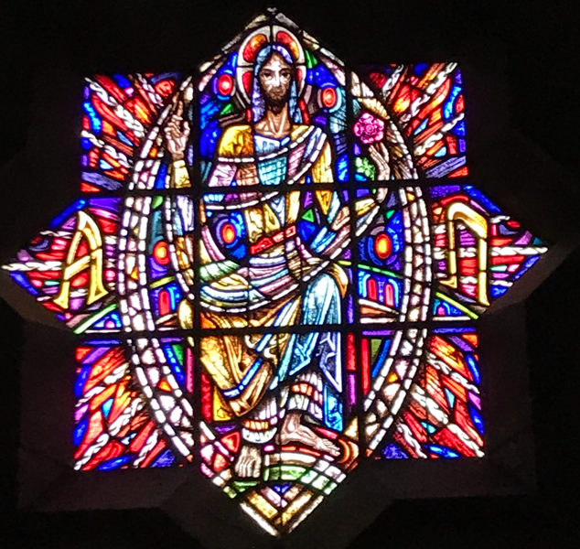

TODAY’S COLLECT

Faithful Creator, whose mercy never fails: deepen our faithfulness to you and to your living Word, Jesus Christ our Lord. Amen

TODAY’S READINGS

Exodus 19: 2-8a
After they set out from Rephidim, they entered the Desert of Sinai, and Israel camped there in the desert in front of the mountain. Then Moses went up to God, and the Lord called to him from the mountain and said, “This is what you are to say to the descendants of Jacob and what you are to tell the people of Israel: ‘You yourselves have seen what I did to Egypt, and how I carried you on eagles’ wings and brought you to myself. Now if you obey me fully and keep my covenant, then out of all nations you will be my treasured possession. Although the whole earth is mine, you[ will be for me a kingdom of priests and a holy nation.’ These are the words you are to speak to the Israelites.” So Moses went back and summoned the elders of the people and set before them all the words the Lord had commanded him to speak. The people all responded together, “We will do everything the Lord has said. ”So Moses brought their answer back to the Lord.

Romans 5: 1-8
Therefore, since we have been justified through faith, we[ have peace with God through our Lord Jesus Christ, through whom we have gained access by faith into this grace in which we now stand. And we boast in the hope of the glory of God. Not only so, but we also glory in our sufferings, because we know that suffering produces perseverance; perseverance, character; and character, hope. And hope does not put us to shame, because God’s love has been poured out into our hearts through the Holy Spirit, who has been given to us. You see, at just the right time, when we were still powerless, Christ died for the ungodly. Very rarely will anyone die for a righteous person, though for a good person someone might possibly dare to die. But God demonstrates his own love for us in this: While we were still sinners, Christ died for us.

Matthew 9:35 – ch.10:8
Then Jesus went about all the cities and villages, teaching in their synagogues, and proclaiming the good news of the kingdom, and curing every disease and every sickness. When he saw the crowds, he had compassion for them, because they were harassed and helpless, like sheep without a shepherd. Then he said to his disciples, ‘The harvest is plentiful, but the labourers are few; therefore ask the Lord of the harvest to send out labourers into his harvest.’ Then Jesus summoned his twelve disciples and gave them authority over unclean spirits, to cast them out, and to cure every disease and every sickness. These are the names of the twelve apostles: first, Simon, also known as Peter, and his brother Andrew; James son of Zebedee, and his brother John; Philip and Bartholomew; Thomas and Matthew the tax-collector; James son of Alphaeus, and Thaddaeus; Simon the Cananaean, and Judas Iscariot, the one who betrayed him. These twelve Jesus sent out with the following instructions: ‘Go nowhere among the Gentiles, and enter no town of the Samaritans, but go rather to the lost sheep of the house of Israel. As you go, proclaim the good news, “The kingdom of heaven has come near.”[ Cure the sick, raise the dead, cleanse the lepers, cast out demons. You received without payment; give without payment.
POST COMMUNION PRAYER
Loving Father, we thank you for feeding us at the supper of your Son: sustain us with your Spirit, that we may serve you here on earth until our joy is complete in heaven, and we share in the eternal banquet with Jesus Christ our Lord. Amen
PRAYER DIARY

This week we remember with thanksgiving the anniversaries of Ethel Udall, Charles Austin, Emma Robinson, Christopher Robins (15th).

Prayer request for healing and other needs: Sue Broatch; Elizabeth Bello; Darrell Campbell; Malcolm George; Sheelagh Gillard; Joyce Nickolay; Pam Storey; Easterine Suresh; Martin Voles; Gary Williams; Angela Zadurian.

Happy Birthday to: Joyce Hughes (18th).

Congratulations to: Raj and Bernadette Rajan who were married on 15th June 1985. May they have a happy day together and many more to come.

Church families: Chris Legg; Jessica; Mia; Aimee; Kennett; Martin, Aldriya Rosanna, Audav Leon Pam Lemar.

The Parish: Our School Groups: Alexandra School, Heathland, Moriah Jewish, Newton Farm, Roxbourne, Rooks Heath.

