NOTICES

ST. STEPHEN’S CHAPEL The Family Flower for June is given by Pam Storey in loving memory of her husband, Michael.

KITCHEN APPEAL You will see posters and a flyer you have been given about our Kitchen Appeal. Anyone who has been in our kitchen can see how much it needs improvement. We want to future proof our new kitchen so it is ready for whatever St Andrew’s provides in the future from café style tea and coffee to full meals on a regular or occasional basis. We aim to replace the kitchen in August. Please give generously.


SUMMER PICNIC Join us on the field TODAY. Just turn up the cost is £2 each. Bring your own food and drink but there will also be burgers and ice creams at no extra cost. There will be live music from Groove Alchemy, who will provide a great atmosphere at the picnic. For little ones there is a bouncy castle and a play area. There are tables and fold up chairs if you need them or just sit on the grass. And today is cooler than lately!

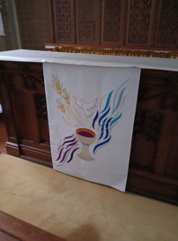
ALTAR FALL There is a new Altar Fall on the Altar in St Stephen's Chapel, which was designed and made by Julia Hemingray, who made our other new pieces. As before, if you would like to make a donation towards the cost in memory of a loved one or to celebrate a special anniversary or occasion, please speak to me or message on 07889 249500. Many thanks Wendy Godwin

FILING CABINET Do you have one you no longer use? If so we need one to store all our Children’s Church materials. Please let Barbara know if you can help.

bank details for one-off payments and gifts -
PCC of St Andrew's Roxbourne Parish
Sort code: 40-11-58 Acc No: 20404810
Please note this is not the account for regular Stewardship Giving - please see Wendy Godwin or Peter Sage for those details (Tel: 07889 249500)

In June, let us pray for sports to be an instrument of peace, encounter and dialogue among cultures and nations; may they promote the values of respect, solidarity and personal growth.
S^{T} ANDREW'S CHURCH, ROXBOURNE
 | 89 Malvern Avenue Harrow HA2 9ER.  020 8422 3633 www.standrewsroxbourne.org.uk  Registered Charity No. 1131727 | 

Star Link

SUNDAY, 28th JUNE TRINITY 4
Roxbournestandrews



8.00 am: Holy Communion
10.00 am: Parish Communion
and Children’s Church
Please come to the Hall after the Service for Coffee, Tea & Fellowship

This Week’s Services |  | Next Sunday 5th July
Monday – Friday 9am Morning Prayer  Wednesday 9.30 Communion |  | 8.00 am: Holy Communion  10.00 am: Parish Communion  Zechariah 9: 9-12; Romans 7: 15-25a; Matthew 11: 16-19 & 25-30
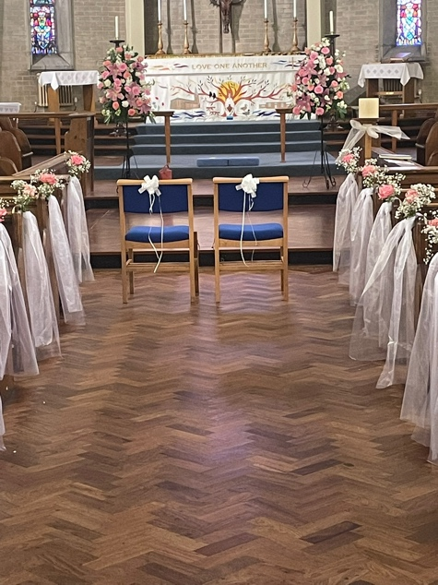
TODAY’S COLLECT

Gracious Father, by the obedience of Jesus you brought salvation to our wayward world: draw us into harmony with your will, that we may find all things restored in him, our Saviour Jesus Christ. Amen

TODAY’S READINGS
Jeremiah 28: 5-9
Then the prophet Jeremiah replied to the prophet Hananiah before the priests and all the people who were standing in the house of the Lord. He said, “Amen! May the Lord do so! May the Lord fulfil the words you have prophesied by bringing the articles of the Lord’s house and all the exiles back to this place from Babylon. Nevertheless, listen to what I have to say in your hearing and in the hearing of all the people: From early times the prophets who preceded you and me have prophesied war, disaster and plague against many countries and great kingdoms. But the prophet who prophesies peace will be recognized as one truly sent by the Lord only if his prediction comes true.”

Romans 6: 12-23
Therefore do not let sin reign in your mortal body so that you obey its evil desires. Do not offer any part of yourself to sin as an instrument of wickedness, but rather offer yourselves to God as those who have been brought from death to life; and offer every part of yourself to him as an instrument of righteousness. For sin shall no longer be your master, because you are not under the law, but under grace. What then? Shall we sin because we are not under the law but under grace? By no means! Don’t you know that when you offer yourselves to someone as obedient slaves, you are slaves of the one you obey—whether you are slaves to sin, which leads to death, or to obedience, which leads to righteousness? But thanks be to God that, though you used to be slaves to sin, you have come to obey from your heart the pattern of teaching that has now claimed your allegiance. You have been set free from sin and have become slaves to righteousness. I am using an example from everyday life because of your human limitations. Just as you used to offer yourselves as slaves to impurity and to ever-increasing wickedness, so now offer yourselves as slaves to righteousness leading to holiness. When you were slaves to sin, you were free from the control of righteousness. What benefit did you reap at that time from the things you are now ashamed of? Those things result in death! But now that you have been set free from sin and have become slaves of God, the benefit you reap leads to holiness, and the result is eternal life. For the wages of sin is death, but the gift of God is eternal life in Christ Jesus our Lord.

Matthew 10: 40-42
‘Whoever welcomes you welcomes me, and whoever welcomes me welcomes the one who sent me. Whoever welcomes a prophet in the name of a prophet will receive a prophet’s reward; and whoever welcomes a righteous person in the name of a righteous person will receive the reward of the righteous; and whoever gives even a cup of cold water to one of these little ones in the name of a disciple—truly I tell you, none of these will lose their reward.’

POST COMMUNION PRAYER
Eternal God, comfort of the afflicted and healer of the broken, you have fed us at the table of life and hope: teach us the ways of gentleness and peace, that all the world may acknowledge the kingdom of your Son Jesus Christ our Lord. Amen

PRAYER DIARY

R.I.P.: Kitan Oyesiku who died in Nigeria recently.

This week we remember with thanksgiving the anniversaries of Clifford Loughton; William Wood (28th); Edmund Watkins, Bob French (29th); Gwen Judge (30th).

Prayer request for healing and other needs: Sue Broatch; Elizabeth Bello; Darrell Campbell; Malcolm George; Sheelagh Gillard; Joyce Nickolay; Pam Storey; Easterine Suresh; Martin Voles; Gary Williams; Angela Zadurian.

Happy Birthday to Kathryn Lancelotte (29th); Lenore Marco – Green; Jonathan Blake (30th); Pam Storey (2nd); Rohan Rawat, Marina Tinsey, Kanghak Lee (3rd); Hang Hak Lee (4th).

Church families: Raj and Bernadette Rajan; Rebecca Raja; Mehender, Mol, Rohan and Roween Rawat; Jonathan, Vicky and Francesca Roast.

The Parish: Dunster Way; Eastcote Lane; Edinburgh Close; Exeter Road; Field End Road; Hamilton Crescent; Harlech Gardens; High Worple; Hodson Close.


CHRISTIAN OUTREACH
St Andrew’s lies in the middle of a very cosmopolitan residential area and provides a Community Centre for all. We run Little Steps (preschool), Messy Church, Children’s Church (primary age), and the Youth Club (primary/secondary age) on a regular basis. Most of these activities are oversubscribed and all could do with more helpers. Can you help?

