NOTICES

ST. STEPHEN’S CHAPEL The Family Flower for July is from the Dowse family in loving memory of husband and father, Peter.

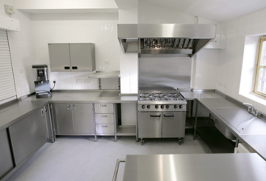
KITCHEN APPEAL You will see posters and a flyer you have been given about our Kitchen Appeal. Anyone who has been in our kitchen can see how much it needs improvement. We want to future proof our new kitchen so it is ready for whatever St Andrew’s provides in the future from café style tea and coffee to full meals on a regular or occasional basis. We aim to replace the kitchen in August. Please give generously.


SUMMER PICNIC Thank you to everyone who supported this. We all had a great time.
The band, Groove Alchemy with Simone as the singer, were brilliant, Chris' burgers and sausages were delicious, the ice creams were cold and the sun shone! Social Committee

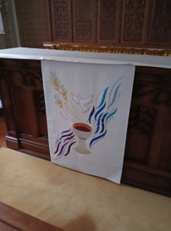
ALTAR FALL There is a new Altar Fall on the Altar in St Stephen's Chapel, which was designed and made by Julia Hemingray, who made our other new pieces. As before, if you would like to make a donation towards the cost in memory of a loved one or to celebrate a special anniversary or occasion, please speak to me or message on 07889 249500. Many thanks Wendy Godwin

MESSY CHURCH The next Messy Church is Saturday 11th July and the theme will be Marvellous Miracles. All offers of help will be gratefully received!
There is no Messy Church in August. Gill Moore

BADMINTON We play badminton on Monday evenings from 8 till 10pm in the main hall. We'd love some new members so please give me a ring if you'd like to come along! Gill Moore

bank details for one-off payments and gifts -
PCC of St Andrew's Roxbourne Parish
Sort code: 40-11-58 Acc No: 20404810
Please note this is not the account for regular Stewardship Giving - please see Wendy Godwin or Peter Sage for those details (Tel: 07889 249500)
S^{T} ANDREW'S CHURCH, ROXBOURNE
 | 89 Malvern Avenue Harrow HA2 9ER.  020 8422 3633 www.standrewsroxbourne.org.uk  Registered Charity No. 1131727 | 

Star Link

SUNDAY, 5th JULY TRINITY 5
Roxbournestandrews



8.00 am: Holy Communion
10.00 am: Parish Communion
and Children’s Church
Please come to the Hall after the Service for Coffee, Tea & Fellowship

This Week’s Services |  | Next Sunday 12th July
Monday – Friday 9am Morning Prayer  Wednesday 9.30 Communion |  | 8.00 am: Holy Communion  10.00 am: Parish Communion  Isaiah 55: 10-13; Romans 8: 1-11;  Matthew 13: 1-9 & 18-23
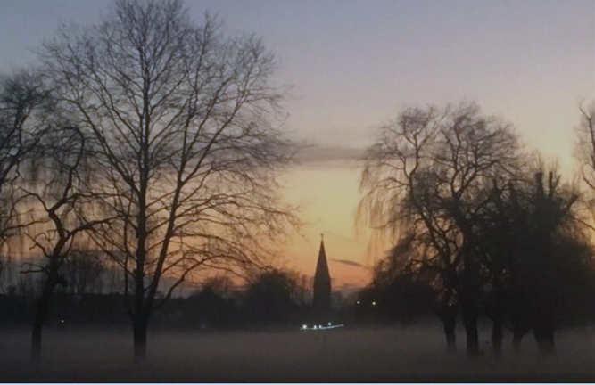
TODAY’S COLLECT

Almighty God, send down upon your Church the riches of your Spirit, and kindle in all who minister the gospel your countless gifts of grace; through Jesus Christ our Lord. Amen
TODAY’S READINGS
Zechariah 9: 9-12
Rejoice greatly, Daughter Zion! Shout, Daughter Jerusalem! See, your king comes to you, righteous and victorious, lowly and riding on a donkey, on a colt, the foal of a donkey. I will take away the chariots from Ephraim and the warhorses from Jerusalem, and the battle bow will be broken. He will proclaim peace to the nations. His rule will extend from sea to sea and from the River to the ends of the earth. As for you, because of the blood of my covenant with you, I will free your prisoners from the waterless pit. Return to your fortress, you prisoners of hope; even now I announce that I will restore twice as much to you.

Romans 7: 15-25a
I do not understand what I do. For what I want to do I do not do, but what I hate I do. And if I do what I do not want to do, I agree that the law is good. As it is, it is no longer I myself who do it, but it is sin living in me. For I know that good itself does not dwell in me, that is, in my sinful nature. For I have the desire to do what is good, but I cannot carry it out. For I do not do the good I want to do, but the evil I do not want to do—this I keep on doing. Now if I do what I do not want to do, it is no longer I who do it, but it is sin living in me that does it. So I find this law at work: Although I want to do good, evil is right there with me. For in my inner being I delight in God’s law; but I see another law at work in me, waging war against the law of my mind and making me a prisoner of the law of sin at work within me. What a wretched man I am! Who will rescue me from this body that is subject to death? Thanks be to God, who delivers me through Jesus Christ our Lord!

Matthew 11: 16-19 & 25-30
But to what will I compare this generation? It is like children sitting in the market-places and calling to one another, “We played the flute for you, and you did not dance; we wailed, and you did not mourn.” For John came neither eating nor drinking, and they say, “He has a demon”; the Son of Man came eating and drinking, and they say, “Look, a glutton and a drunkard, a friend of tax-collectors and sinners!” Yet wisdom is vindicated by her deeds.’ At that time Jesus said, ‘I thank you, Father, Lord of heaven and earth, because you have hidden these things from the wise and the intelligent and have revealed them to infants; yes, Father, for such was your gracious will. All things have been handed over to me by my Father; and no one knows the Son except the Father, and no one knows the Father except the Son and anyone to whom the Son chooses to reveal him. ‘Come to me, all you that are weary and are carrying heavy burdens, and I will give you rest. Take my yoke upon you, and learn from me; for I am gentle and humble in heart, and you will find rest for your souls. For my yoke is easy, and my burden is light.’

POST COMMUNION PRAYER
Grant, O Lord, we beseech you, that the course of this world may be so peaceably ordered by your governance, that your Church may joyfully serve you in all godly quietness; through Jesus Christ our Lord. Amen

PRAYER DIARY

This week we remember with thanksgiving the anniversaries of Frederick Cann (7th); Donald Crouch (8th); Margaret Blay; Jack Phillips (10th); Gabriel Jordan (11th); George Scott; Derick Harrrowell; Peter Yorke, Norman Slater (12th).

Prayer request for healing and other needs: Sue Broatch; Elizabeth Bello; Malcolm George; Joyce Nickolay; Pam Storey; Easterine Suresh; Martin Voles; Gary Williams; Angela Zadurian.

Happy Birthday to Vinod Danny Chandran; Da – Hee Jeon (8th).

Church families: Peter and Georgina Sage; Theepia Sanjopan; Omid and Sally Sarafan; Enid and Douglas Scott – Kerr; Ray Stockwell; Easterine, Koushi and Kouthaman Suresh.

The Parish: Holyrood Avenue; Ivy Close; Kenilworth Avenue; Kings Court; Kings Road; Leamington Crescent; Lulworth Close; Lulworth Gardens; Lynton Road.

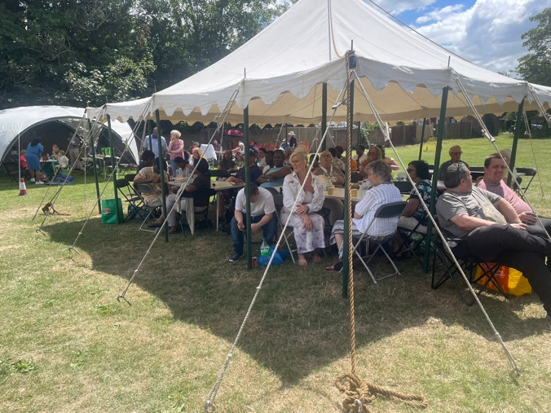
ST. ANDREW’S CHURCH
We are a diverse and inclusive church and want everyone to feel part of St Andrew’s.
We are lucky to have our field which is used for Social Events, as shown in the photo and also for Youth Club, Holiday Club, Scouts and many other activities.
On Tuesday 7th I will present our application for a grant to buy more shelters to protect us from sun and rain and allow more to use our field. Pray for me and I will let everyone know if our bid is successful.
Susan McLeod

