NOTICES

AUGUST SERVICES There are no Sunday 8am or Wednesday 9.30am services in the month of August.

KITCHEN UPDATE Work is going well, last week it was just a shell with all the

TEA AND COFFEE SUNDAY MORNINGS will continue in August but in the Youth Centre while the kitchen is out of action.

ST STEPHEN’S CHAPEL The Family Flower for August has been given by Sue Brown in memory of her mother, CathTaylor.

CHILDREN’S CHURCH
This summer, instead of a Holiday Club we are focusing on outings for our growing Children’s Church.

BENCHES Many people come and sit on our benches outside St Andrew’s but they are looking rather sad and could do with rubbing down and revarnishing. Dry weather is the time to do outside jobs though not too hot. Any offers? If you’re not into painting or would rather be inside I can always think of other tasks to do!

HARROW FOOD BANK There is a box for donations to the Harrow Food Bank at the back of the church. Last month we collected 20.25 kg of food and other items. Let us try to better that collection this month. Thank you all.

ST. PAUL’S CATHEDRAL Why not go up to town and pay a visit to St. Paul’s Cathedral? We have 4 free entry cards which can be used at any time. See me and will pass them to you, but do remember to return them for the next person to use.

SOCIAL COMMITTEE August is a quiet month but there is lots to look forward to. Lyndon’s final church service will be on Sunday 27th September with the celebration of his 14 years of service at St. Andrew’s afterwards. Two weeks later on Sunday 11th October is our Harvest Festival with Bishop Lusa - another celebration!

bank details for one-off payments and gifts -
PCC of St Andrew's Roxbourne Parish
Sort code: 40-11-58 Acc No: 20404810
Please note this is not the account for regular Stewardship Giving - please see Wendy Godwin or Peter Sage for those details (Tel: 07889 249500
S^{T} ANDREW'S CHURCH, ROXBOURNE
 | 89 Malvern Avenue Harrow HA2 9ER.  020 8422 3633 www.standrewsroxbourne.org.uk  Registered Charity No. 1131727 | 

Star Link

SUNDAY, 9th AUGUST TRINITY 10
Welcome to Rev Irene Lawrence, today’s celebrant.
Roxbournestandrews



10.00 am: Parish Communion
Please come to the Youth Centre after the Service for Coffee, Tea & Fellowship

This Week’s Services |  | Next Sunday 16THAugust
Monday – Friday 9am Morning Prayer |  | 10.00 am: Parish Communion  I Kings 19: 9-18; Romans 10: 5-15;  Matthew 14: 22-33
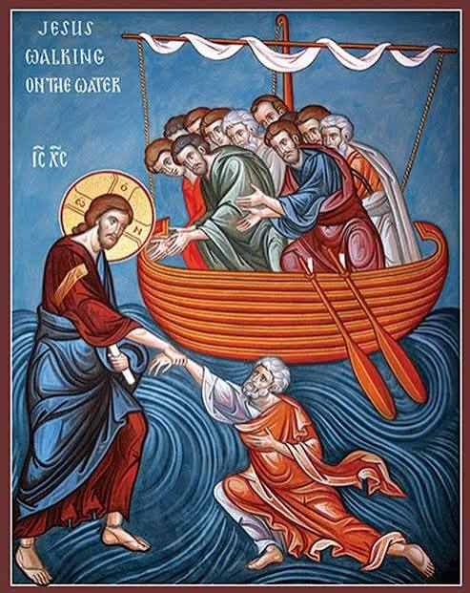

TODAY’S COLLECT

Lord of heaven and earth, as Jesus taught his disciples to be persistent in prayer, give us patience and courage never to lose hope, but always to bring our prayers before you; through Jesus Christ our Lord. Amen

TODAY’S READINGS
I Kings 19: 9-18
There he went into a cave and spent the night. And the word of the Lord came to him: “What are you doing here, Elijah?” He replied, “I have been very zealous for the Lord God Almighty. The Israelites have rejected your covenant, torn down your altars, and put your prophets to death with the sword. I am the only one left, and now they are trying to kill me too.” The Lord said, “Go out and stand on the mountain in the presence of the Lord, for the Lord is about to pass by.” Then a great and powerful wind tore the mountains apart and shattered the rocks before the Lord, but the Lord was not in the wind. After the wind there was an earthquake, but the Lord was not in the earthquake. After the earthquake came a fire, but the Lord was not in the fire. And after the fire came a gentle whisper. When Elijah heard it, he pulled his cloak over his face and went out and stood at the mouth of the cave. Then a voice said to him, “What are you doing here, Elijah?” He replied, “I have been very zealous for the Lord God Almighty. The Israelites have rejected your covenant, torn down your altars, and put your prophets to death with the sword. I am the only one left, and now they are trying to kill me too.” The Lord said to him, “Go back the way you came, and go to the Desert of Damascus. When you get there, anoint Hazael king over Aram. Also, anoint Jehu son of Nimshi king over Israel, and anoint Elisha son of Shaphat from Abel Meholah to succeed you as prophet. Jehu will put to death any who escape the sword of Hazael, and Elisha will put to death any who escape the sword of Jehu. Yet I reserve seven thousand in Israel—all whose knees have not bowed down to Baal and whose mouths have not kissed him.”

Romans 10: 5-15
Moses writes this about the righteousness that is by the law: “The person who does these things will live by them.” But the righteousness that is by faith says: “Do not say in your heart, ‘Who will ascend into heaven?’” (that is, to bring Christ down) “or ‘Who will descend into the deep?’” (that is, to bring Christ up from the dead). But what does it say? “The word is near you; it is in your mouth and in your heart,” that is, the message concerning faith that we proclaim: If you declare with your mouth, “Jesus is Lord,” and believe in your heart that God raised him from the dead, you will be saved. For it is with your heart that you believe and are justified, and it is with your mouth that you profess your faith and are saved. As Scripture says, “Anyone who believes in him will never be put to shame.” For there is no difference between Jew and Gentile—the same Lord is Lord of all and richly blesses all who call on him, for, “Everyone who calls on the name of the Lord will be saved.” How, then, can they call on the one they have not believed in? And how can they believe in the one of whom they have not heard? And how can they hear without someone preaching to them? And how can anyone preach unless they are sent? As it is written: “How beautiful are the feet of those who bring good news!”

Matthew 14: 22-33
Immediately he made the disciples get into the boat and go on ahead to the other side, while he dismissed the crowds. And after he had dismissed the crowds, he went up the mountain by himself to pray. When evening came, he was there alone, but by this time the boat, battered by the waves, was far from the land, for the wind was against them. And early in the morning he came walking towards them on the lake. But when the disciples saw him walking on the lake, they were terrified, saying, ‘It is a ghost!’ And they cried out in fear. But immediately Jesus spoke to them and said, ‘Take heart, it is I; do not be afraid.’ Peter answered him, ‘Lord, if it is you, command me to come to you on the water.’ He said, ‘Come.’ So Peter got out of the boat, started walking on the water, and came towards Jesus. But when he noticed the strong wind, he became frightened, and beginning to sink, he cried out, ‘Lord, save me!’ Jesus immediately reached out his hand and caught him, saying to him, ‘You of little faith, why did you doubt?’ When they got into the boat, the wind ceased. And those in the boat worshipped him, saying, ‘Truly you are the Son of God.’

POST COMMUNION PRAYER

God of our pilgrimage, you have willed that the gate of mercy should stand open for those who trust in you: look upon us with your favour that we who follow the path of your will may never wander from the way of life; through Jesus Christ our Lord. Amen
PRAYER DIARY

This week we remember with thanksgiving the anniversary of: Diane Sonuga
(10th); William Nickolay (13th); Beryl Crowhurst (14th); Cathy Taylor, David Hughes
(15th).

Prayer request for healing and other needs: Sue Broatch; Elizabeth Bello; Megan Fox; Malcolm George; Lenore Marcano-Green; Joyce Nickolay; Gill Rafferty Pam Storey; Easterine Suresh; Belinda Szamanski, Gary Williams; Angela Zadurian.

Happy Birthday to Aukar Leon (9th); Stefanie Lawrence (10th); Diane Bidder, Emaillda Mushonga (12th); Rev.Anna Dias (13th); Solomon Wong (14th); Keira Grice (15th).

Congratulations to: Roger and Gill Moore who were married on 14th August 1971.May they have a happy day together and many more to follow.

Church families: Kemi and Ayo Aina; David, Andrea, Angela Alleyne; Ola Amode.

The Parish: Worple Close; Worple Way; Warwick Avenue; Waverley Road; Yeading Avenue.

