NOTICES

KITCHEN UPDATE It will be ready for use next Sunday, prepare to be impressed! Envelopes are still in the pews if you would like to contribute to this project.

TEA AND COFFEE SUNDAY MORNINGS will take place in the Youth Centre today but back in the main hall fron next Sunday onwards.

ST STEPHEN’S CHAPEL The Family Flower for August has been given by Sue Brown in memory of her mother, CathTaylor.

ELIZEBETH TINSAY Thanks to all who came to my aid last Sunday when I had a bad fall when I left the Church. Fortunately there were no broken bones but it has not helped the problem I already have. Thank you so much for being there.
Elizebeth

HARROW FOOD BANK There is a box for donations to the Harrow Food Bank at the back of the church. Last month we collected 20.25 kg of food and other items. Let us try to better that collection this month. Thank you all.

ST. PAUL’S CATHEDRAL Why not go up to town and pay a visit to St. Paul’s Cathedral? We have 4 free entry cards which can be used at any time. See me and will pass them to you, but do remember to return them for the next person to use.

DATES FOR YOUR DIARY
27th September Lyndon and Barbara’s final service and celebration
11th October Harvest festival with Bishop Lusa and a shared lunch
17th October Quiz night
25th October Big Brekkie
21st November Christmas Mark
Each of these events rely on a group of people to organise them
but always need more helpers. St Andrew’s needs YOU.

bank details for one-off payments and gifts -
PCC of St Andrew's Roxbourne Parish
Sort code: 40-11-58 Acc No: 20404810
Please note this is not the account for regular Stewardship Giving - please see Wendy Godwin or Peter Sage for those details (Tel: 07889 249500

S^{T} ANDREW'S CHURCH, ROXBOURNE
 | 89 Malvern Avenue Harrow HA2 9ER.  020 8422 3633 www.standrewsroxbourne.org.uk  Registered Charity No. 1131727 | 

Star Link

SUNDAY, 30th AUGUST TRINITY 13

Welcome to Rev Jane Morris, today’s celebrant
Roxbournestandrews



10.00 am: Parish Communion
Please come to the Youth Centre after the Service for Coffee, Tea & Fellowship

This Week’s Services |  | Next Sunday 6th September
Monday – Friday 9am Morning Prayer |  | 8.00 am: Holy Communion  10.00 am: Parish Communion  Ezekiel 33: 7-11; Romans 13: 8-14;  Matthew 18: 15-20
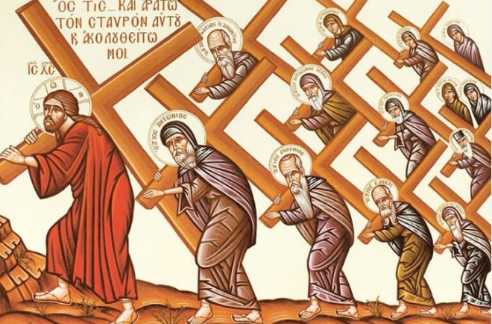

TODAY’S COLLECT

Almighty God, you search us and know us: may we rely on you in strength and rest on you in weakness, now and in all our days; through Jesus Christ our Lord. Amen

TODAY’S READINGS

Jeremiah 15: 15-21
Lord, you understand; remember me and care for me. Avenge me on my persecutors. You are long-suffering—do not take me away; think of how I suffer reproach for your sake. When your words came, I ate them; they were my joy and my heart’s delight, for I bear your name, Lord God Almighty. I never sat in the company of revellers, never made merry with them; I sat alone because your hand was on me and you had filled me with indignation. Why is my pain unending and my wound grievous and incurable? You are to me like a deceptive brook, like a spring that fails. Therefore this is what the Lord says: “If you repent, I will restore you that you may serve me; if you utter worthy, not worthless, words, you will be my spokesman. Let this people turn to you, but you must not turn to them. I will make you a wall to this people, a fortified wall of bronze; they will fight against you but will not overcome you, for I am with you to rescue and save you,” declares the Lord. “I will save you from the hands of the wicked and deliver you from the grasp of the cruel.”

Romans 12: 9-21
Love must be sincere. Hate what is evil; cling to what is good. Be devoted to one another in love. Honour one another above yourselves. Never be lacking in zeal, but keep your spiritual fervour, serving the Lord. Be joyful in hope, patient in affliction, faithful in prayer. Share with the Lord’s people who are in need. Practice hospitality. Bless those who persecute you; bless and do not curse. Rejoice with those who rejoice; mourn with those who mourn. Live in harmony with one another. Do not be proud, but be willing to associate with people of low position. Do not be conceited. Do not repay anyone evil for evil. Be careful to do what is right in the eyes of everyone. If it is possible, as far as it depends on you, live at peace with everyone. Do
not take revenge, my dear friends, but leave room for God’s wrath, for it is written: “It is mine to avenge; I will repay,” says the Lord. On the contrary: “If your enemy is hungry, feed him; if he is thirsty, give him something to drink. In doing this, you will heap burning coals on his head.” Do not be overcome by evil, but overcome evil with good.

Matthew 16: 21-28
From that time on, Jesus began to show his disciples that he must go to Jerusalem and undergo great suffering at the hands of the elders and chief priests and scribes, and be killed, and on the third day be raised. And Peter took him aside and began to rebuke him, saying, ‘God forbid it, Lord! This must never happen to you.’ But he turned and said to Peter, ‘Get behind me, Satan! You are a stumbling-block to me; for you are setting your mind not on divine things but on human things.’ Then Jesus told his disciples, ‘If any want to become my followers, let them deny themselves and take up their cross and follow me. For those who want to save their life will lose it, and those who lose their life for my sake will find it. For what will it profit them if they gain the whole world but forfeit their life? Or what will they give in return for their life? ‘For the Son of Man is to come with his angels in the glory of his Father, and then he will repay everyone for what has been done. Truly I tell you, there are some standing here who will not taste death before they see the Son of Man coming in his kingdom.’

POST COMMUNION PRAYER

God our creator, you feed your children with the true manna, the living bread from heaven: let this holy food sustain us through our earthly pilgrimage until we come to that place where hunger and thirst are no more; through Jesus Christ our Lord. Amen

PRAYER DIARY

RIP: Dolly Parton

This week we remember with thanksgiving the anniversary of: David Bendall,
Peter Wood (1st), Eileen Shadbolt (3rd), Maurice power (5th).

Prayer request for healing and other needs: Sue Broatch; Elizabeth Bello; Megan Fox; Lenore Marcano-Green; Joyce Nickolay; Gill Rafferty Pam Storey; Easterine Suresh; Belinda Szamanski, Gary Williams; Angela Zadurian.

Happy Birthday to: Marion Twentyman, Solomon Gnanarj, Bernrd Borty (30th)
Stephanie Sadler (2nd), Maxim Animashhaan (3rd).

Congratulations to: John and Diane Bidder who married on 1st September 1990.
Alan and Carolyn who married on 2nd September 1989 and Simon and Eleanor who married om 4th September 2021. May each couple have a happy day together.

Church families: John and Rose Chamberline, Vinrod Danny, Suja Jeney and Sherin
Chandran, Pauline and Angel Conway, Robert Crowhurst.

The Parish: Holyrood Avenue, Ivy Close, Kenilworth Avenue, Kings Court,
Leamington Crescent, Lulworth Close, Lulworth Gardens and Lynton Road.



