NOTICES

ST STEPHEN’S CHAPEL The Family Flower for October has been donated by Sheelagh Gillard in memory of her husband John.

FLOWERS The high altar flowers have been given by Letitia Timis in memory of her father Vasile.
QUIZ NIGHT was fun and we raised money for our chosen charities.

HARVEST CHARITY As we celebrate God’s gifts to us it’s time to think of others so we are supporting Harrow Food Bank through Harvest time.

HARVEST BREKKIE Harvest celebrations continue on Sunday 25th October we have the wonderful breakfast to enjoy. From 8.45 to 9.45am breakfast will be served from the kitchen to eat with friends in the main hall. The choice is yours, from a simple croissant to full English breakfast.

ALL SOULS' MEMORIAL SERVICE: We shall be holding this Service on Sunday, 1st. November with the 10am Eucharist. If you wish to have any loved ones' name read, please write them clearly on the sheets at the back of the church. If family names can be linked please write them together. Enid Scott-Kerr.

CHRISTMAS MARKET Yes, Christmas is coming! The great St. Andrew’s Christmas Market is taking place on Saturday 21st November. We need Christmas decorations, in date bottles and toiletries, bags and scarves, any unwanted presents for Sue Jull's tombola, any items for Susan McLeod's hamper, children's toys and books.
Please put any donations at the back of the church. Thank you

bank details for one-off payments and gifts -
PCC of St Andrew's Roxbourne Parish
Sort code: 40-11-58 Acc No: 20404810
Please note this is not the account for regular Stewardship Giving - please see Wendy Godwin or Peter Sage for those details (Tel: 07889 249500

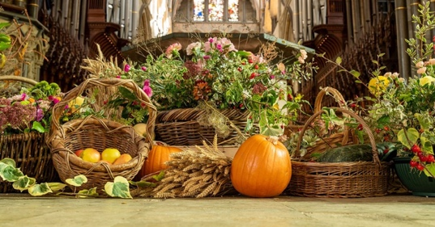
Come and join our Harvest Festival
S^{T} ANDREW'S CHURCH, ROXBOURNE
 | 89 Malvern Avenue Harrow HA2 9ER.  020 8422 3633 www.standrewsroxbourne.org.uk  Registered Charity No. 1131727 | 

Star Link

SUNDAY, 18^{h} OCTOBER 2026 TRINITY 20

Welcome to Bishop Lusa, Today’s Celebrant
Roxbournestandrews



to
8.00 am: Holy Communion
10.00 am: Parish Communion
and Children’s Church
Please come to the Hall after the Service for Coffee, Tea & Fellowship

This Week’s Services |  | Next Sunday 11th October
Monday – Friday 9am Morning Prayer  Wednesday 9.30 Communion |  | 8.00 am: Holy Communion  10.00 am: Parish Communion  I Kings 8: 22-30; Hebrews 12: 18-24;  Matthew 21: 12-16

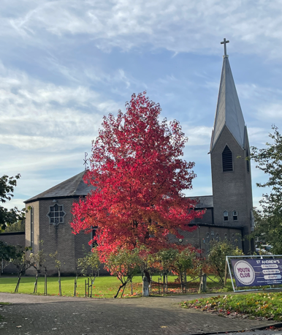
TODAY’S COLLECT

Creator God, you made the goodness of the land, the riches of the sea and the rhythm of the seasons; as we thank you for the harvest, may we cherish and respect this planet and its peoples, through Jesus Christ our Lord. Amen

TODAY’S READINGS

Deuteronomy 28: 1-14
If you fully obey the Lord your God and carefully follow all his commands I give you today, the Lord your God will set you high above all the nations on earth. All these blessings will come on you and accompany you if you obey the Lord your God: You will be blessed in the city and blessed in the country. The fruit of your womb will be blessed, and the crops of your land and the young of your livestock—the calves of your herds and the lambs of your flocks. Your basket and your kneading trough will be blessed. You will be blessed when you come in and blessed when you go out. The Lord will grant that the enemies who rise up against you will be defeated before you. They will come at you from one direction but flee from you in seven. The Lord will send a blessing on your barns and on everything you put your hand to. The Lord your God will bless you in the land he is giving you. The Lord will establish you as his holy people, as he promised you on oath, if you keep the commands of the Lord your God and walk in obedience to him. Then all the peoples on earth will see that you are called by the name of the Lord, and they will fear you. The Lord will grant you abundant prosperity—in the fruit of your womb, the young of your livestock and the crops of your ground—in the land he swore to your ancestors to give you. The Lord will open the heavens, the storehouse of his bounty, to send rain on your land in season and to bless all the work of your hands. You will lend to many nations but will borrow from none. The Lord will make you the head, not the tail. If you pay attention to the commands of the Lord your God that I give you this day and carefully follow them, you will always be at the top, never at the bottom. Do not turn aside from any of the commands I give you today, to the right or to the left, following other gods and serving them.

II Corinthians 9: 6-15
Remember this: Whoever sows sparingly will also reap sparingly, and whoever sows generously will also reap generously. Each of you should give what you have decided in your heart to give, not reluctantly or under compulsion, for God loves a cheerful giver. And God is able to bless you abundantly, so that in all things at all times, having all that you need, you will abound in every good work. As it is written: “They have freely scattered their gifts to the poor; their righteousness endures forever.” Now he who supplies seed to the sower and bread for food will also supply and increase your store of seed and will enlarge the harvest of your righteousness. You will be enriched in every way so that you can be generous on every occasion, and through us your generosity will result in thanksgiving to God. This service that you perform is not only supplying the needs of the Lord’s people but is also overflowing in many expressions of thanks to God. Because of the service by which you have proved yourselves, others will praise God for the obedience that accompanies your confession of the gospel of Christ, and for your generosity in sharing with them and with everyone else. And in their prayers for you their hearts will go out to you, because of the surpassing grace God has given you. Thanks be to God for his indescribable gift! learned or received or heard from me, or seen in me—put it into practice. And the God of peace will be with you.

Luke 12: 16-30Then he told them a parable: ‘The land of a rich man produced abundantly. And he thought to himself, “What should I do, for I have no place to store my crops?” Then he said, “I will do this: I will pull down my barns and build larger ones, and there I will store all my grain and my goods. And I will say to my soul, Soul, you have ample goods laid up for many years; relax, eat, drink, be merry.” But God said to him, “You fool! This very night your life is being demanded of you. And the things you have prepared, whose will they be?” So it is with those who store up treasures for themselves but are not rich towards God.’ He said to his disciples, ‘Therefore I tell you, do not worry about your life, what you will eat, or about your body, what you will wear. For life is more than food, and the body more than clothing. Consider the ravens: they neither sow nor reap, they have neither storehouse nor barn, and yet God feeds them. Of how much more value are you than the birds! And can any of you by worrying add a single hour to your span of life? If then you are not able to do so small a thing as that, why do you worry about the rest? Consider the lilies, how they grow: they neither toil nor spin; yet I tell you, even Solomon in all his glory was not clothed like one of these. But if God so clothes the grass of the field, which is alive today and tomorrow is thrown into the oven, how much more will he clothe you—you of little faith! And do not keep striving for what you are to eat and what you are to drink, and do not keep worrying. For it is the nations of the world that strive after all these things, and your Father knows that you need them.

POST COMMUNION PRAYER

Lord of the harvest, with joy we have offered thanksgiving for your love in creation and have shared in the bread and the wine of the kingdom: by your grace plant within us a reverence for all that you give us and make us generous and wise stewards of the good things we enjoy; through Jesus Christ our Lord. Amen

PRAYER DIARY

This week we remember with thanksgiving the anniversaries of: Jill Huguette Maynard (22nd); Malcolm Blanch; Louise Greyson (23rd); Ruth Wolfe (24th).

Prayer request for healing and other needs: Elizabeth Bello; Megan Fox; Joyce Nickolay; Kerry Poulton, Gill Rafferty Pam Storey; Easterine Suresh; Gary Williams; Angela Zadurian.

Happy Birthday to: Audvik Gupta (19th); Sorina Purice (21st); Andrea Alleyne; Bailey Bortey (24th).

Church families: Kemi and Ayo Aina; Andrea; Angela and David Alleyne; Ola Amode; Deke Adebambo.

The Parish: Our School Groups: Alexandra Special; Heathland; Moriah Jewish; Newton Farm; Roxbourne; Rooks Heath

