NOTICES

DEDICATION SUNDAY Today is a day to ask what the church is, what it has been, and what it will become. It is a day to recall and discover what we are to do and to be. It is a day to remember and to be re-membered as the body of Christ.

ST STEPHEN’S CHAPEL The Family Flower for October has been donated by Sheelagh Gillard in memory of her husband John.

QUIZ NIGHT was fun and we raised £1092.50 for our chosen charities.

HARVEST CHARITY We sent 115.75 kg of food for Harrow Food Bank last week. Keep giving this Harvest time!

HARVEST BREKKIE Did you enjoy your Brekkie today? All the money raised will go to Harrow Food Bank. Thankyou to Rebecca and her team for supplying and cooking such a wonderful feast for us all.

CHILDREN’S CHURCH There will be no Sunday School next week 1st November for Half Term.

ALL SOULS' MEMORIAL SERVICE: We shall be holding this Service on Sunday, 1st. November with the 10am Eucharist. If you wish to have any loved ones' name read, please write them clearly on the sheets at the back of the church. If family names can be linked please write them together. Enid Scott-Kerr.

CHRISTMAS MARKET Yes, Christmas is coming! The great St. Andrew’s Christmas Market is taking place on Saturday 21st November. We need Christmas decorations, in date bottles and toiletries, bags and scarves, any unwanted presents for Sue Jull's tombola, any items for Susan McLeod's hamper, children's toys and books. Please put any donations at the back of the church. Thank you


COMING SOON ANGEL TREE is part of a Christian organisation (Prison Fellowship) which is focussed on sharing the Gospel with prisoners in the UK and across the world. ANGEL TREE arranges for Christmas presents to be sent on behalf of prisoners, because it is impossible for them to arrange this themselves. Please let me know if you would be interested in supporting Angel Tree. Thank you. Keith Nicholls keithjnicholls@gmail.com 07769 738 495

bank details for one-off payments and gifts -
PCC of St Andrew's Roxbourne Parish
Sort code: 40-11-58 Acc No: 20404810
Please note this is not the account for regular Stewardship Giving - please see Wendy Godwin or Peter Sage for those details (Tel: 07889 249500
S^{T} ANDREW'S CHURCH, ROXBOURNE
 | 89 Malvern Avenue Harrow HA2 9ER.  020 8422 3633 www.standrewsroxbourne.org.uk  Registered Charity No. 1131727 | 

Star Link

SUNDAY, 25^{h} OCTOBER 2026 DEDICATION

Welcome to Bishop Pete, Today’s Celebrant
Roxbournestandrews



to
8.00 am: Holy Communion
10.00 am: Parish Communion
and Children’s Church
Please come to the Hall after the Service for Coffee, Tea & Fellowship

This Week’s Services |  | Next Sunday 1st November
Monday – Friday 9am Morning Prayer  Wednesday 9.30 Communion |  | 8.00 am: Holy Communion  10.00 am: Parish Communion  Revelation 7: 9-17; I John 3: 1-3; Matthew 5: 1-12

TODAY’S COLLECT

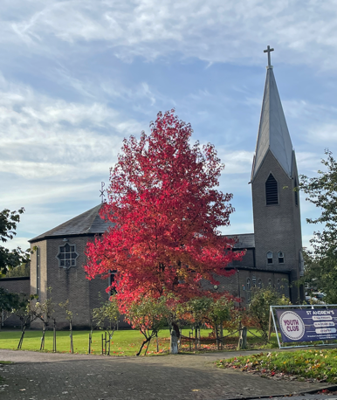
Almighty God, to whose glory we celebrate the dedication of this house of prayer: we praise you for the many blessings you have given to those who worship you here: and we pray that all who seek you in this place may find you, and, being filled with the Holy Spirit, may become a living temple acceptable to you; through Jesus Christ your Son our Lord, who is alive and reigns with you, in the unity of the Holy Spirit, one God, now and for ever. Amen

TODAY’S READINGS

I Kings 8: 22-30
Solomon stood before the altar of the Lord in the presence of all the assembly of Israel, and spread out his hands to heaven. He said, ‘O Lord, God of Israel, there is no God like you in heaven above or on earth beneath, keeping covenant and steadfast love for your servants who walk before you with all their heart, the covenant that you kept for your servant my father David as you declared to him; you promised with your mouth and have this day fulfilled with your hand. Therefore, O Lord, God of Israel, keep for your servant my father David that which you promised him, saying, “There shall never fail you a successor before me to sit on the throne of Israel, if only your children look to their way, to walk before me as you have walked before me.” Therefore, O God of Israel, let your word be confirmed, which you promised to your servant my father David. ‘But will God indeed dwell on the earth? Even heaven and the highest heaven cannot contain you, much less this house that I have built! Have regard to your servant’s prayer and his plea, O Lord my God, heeding the cry and the prayer that your servant prays to you today; that your eyes may be open night and day towards this house, the place of which you said, “My name shall be there”, that you may heed the prayer that your servant prays towards this place. Hear the plea of your servant and of your people Israel when they pray towards this place; O hear in heaven your dwelling-place; heed and forgive.’

Hebrews 12: 18-24;
You have not come to something that can be touched, a blazing fire, and darkness, and gloom, and a tempest, and the sound of a trumpet, and a voice whose words made the hearers beg that not another word be spoken to them. (For they could not endure the order that was given, ‘If even an animal touches the mountain, it shall be stoned to death.’ Indeed, so terrifying was the sight that Moses said, ‘I tremble with fear.’) But you have come to Mount Zion and to the city of the living God, the heavenly Jerusalem, and to innumerable angels in festal gathering, and to the assembly of the firstborn who are enrolled in heaven, and to God the judge of all, and to the spirits of the righteous made perfect, and to Jesus, the mediator of a new covenant, and to the sprinkled blood that speaks a better word than the blood of Abel.

Matthew 21: 12-16
Then Jesus entered the temple and drove out all who were selling and buying in the temple, and he overturned the tables of the money-changers and the seats of those who sold doves. He said to them, ‘It is written, “My house shall be called a house of prayer”; but you are making it a den of robbers.’ The blind and the lame came to him in the temple, and he cured them. But when the chief priests and the scribes saw the amazing things that he did, and heard the children crying out in the temple, ‘Hosanna to the Son of David’, they became angry and said to him, ‘Do you hear what these are saying?’ Jesus said to them, ‘Yes; have you never read, “Out of the mouths of infants and nursing babies you have prepared praise for yourself”?’

POST COMMUNION PRAYER

Father in heaven, whose Church on earth is a sign of your heavenly peace, an image of the new and eternal Jerusalem: grant to us in the days of our pilgrimage that, fed with the living bread of heaven, and united in the body of your Son, we may be the temple of your presence, the place of your glory on earth, and a sign of your peace in the world; through Jesus Christ our Lord.
Amen

PRAYER DIARY

This week we remember with thanksgiving the anniversaries of: John Bateman; Cynthia Clench; Raymond Horsley (28th); Frank Pugh; Ann Ginger (29th); George Sandell (30th).

Prayer request for healing and other needs: Elizabeth Bello; Joyce Nickolay; Kerry Poulton, Pam Storey; Easterine Suresh; Gary Williams; Angela Zadurian.

Happy Birthday to: Letitia Mihali (26th); Jonathan Roast (27th); Martin Leon (29th); Eunso Leon (30th)

Congratulations to: Michael and Brenda Udall who were married on 25th October 1975. May they have a happy day together and many more to follow

Church families: Sue Barnard; Elizabeth and Kayode Bello; Randy Berkley; Diane and John Bidder; John Blanchard; Bailey; Riley; Shannel and Bernard Bortey.

The Parish: Alexandra Avenue; Berriton Road; Bodmin Close; Brookside Close; Cannon Lane; Capthorne Avenue; Carlisle Close; Drake Court; Drake Road.
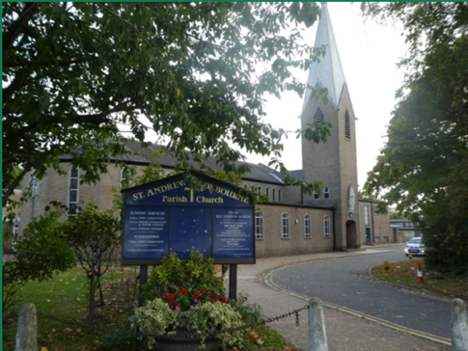
SAINT ANDREW’S CHURCH
was built and opened in 1957, 69 years ago. Local people raised £4000 when average wages were only £8 a week. The rest of the money came from the destruction of other churches during World War 2, particularly St. Stephen’s, Poplar. It is a listed building mainly due to our beautiful stained glass windows. The Feast of the Dedication is the annual celebration of the day of the dedication of our church.

